A BETTER RINGMASTER FOR THE CIRCUS:
A STUDY OF FINE ARTS DEPARTMENT LEADERSHIP

R. ANDREW STRICKLAND
SEPTEMBER 8, 2008

IN PARTIAL COMPLETION OF
CERTIFICATE OF ADVANCED GRADUATE STUDY
INTEGRATED TEACHING THROUGH THE ARTS
LESLEY UNIVERSITY GRADUATE SCHOOL OF ARTS AND SOCIAL SCIENCES
Abstract
This study is focused on the research area of dedicated fine arts departments (departments made up of only fine arts subjects) and strategies for leading them. It specifically addresses the following question: what are personal qualities, skills, and knowledge needed for a department chairperson to effectively manage the unique aspects and challenges of a dedicated fine arts department?
This project used an online survey to pose questions to fine arts educators teaching in schools affiliated with the Georgia Independent School Association (GISA). The survey asked quantitative questions for the sake of determining the demographics of the respondents and qualitative questions searching for in-depth responses about the specific traits of a fine arts department, the challenges the fine arts department faces, and the leadership needed for the fine arts department to thrive. Several questions asked the respondents to make an artistic response to a question, choosing a work of art (visual, dramatic, musical, or otherwise) to represent their answer.
The survey had over 150 respondents. Through their responses, the teachers isolated five major challenges to fine arts departments: communication within the department and beyond, insufficient funding, insufficient facilities, the struggle to find a voice for the fine arts in the school and local community, and the difficulties with the inherent dichotomy of being both an artist and an arts educator. These five challenges were then studied individually with respondents suggesting leadership strategies and possible solutions to the problems.
The information in the study is useful for both novice and experienced fine arts leaders and teachers. The data reflects numerous shared difficulties and approaches and solutions to these issues. The researcher also recommends the creation of a national community of fine arts education leaders to continue the work begun with this study.
Table of Contents

Introduction to the Study 5
Area of Focus 8
Literature Review 10
Fine Arts Departments and Their Leaders 10
The Survey as a Method of Data Collection 16
Theatre as a Means of Data Analysis and Presentation 17
Methodology 19
Original Research Proposal – Pilot Study 19
Survey Questions 20
Refinements to Original Proposal 22
Second Phase of the Study 24
Coding and Analysis 26
Analysis and Findings 28
Initial Skip Logic Question – Second Phase Study 28
Demographics – Pilot and Second Phase Studies 29
Qualitative Questions Posed to All Respondents 40
Qualitative Questions Posed to Department Heads, Current and Former 52
Qualitative Question Posed to Non-Department Heads 57
Questions Posed Only in the Second Phase Study 59
Fine Arts Challenge 1: Problems with Communication 61
Fine Arts Challenge 2: Insufficient Resources and/or Funding 62
Fine Arts Challenge 3: Insufficient Facilities 64
Fine Arts Challenge 4: Inherent Dichotomy of Teaching Fine Arts 65
Fine Arts Challenge 5: Helping the Fine Arts Find a Voice 66
Artistic Analysis: The Cirque du F.A. 68
Additional Questions Posed to Second Phase Study Respondents 82
Action Plan 84
Conclusion 86
References 87
Introduction to the Study

My career has been split between theatre education and professional theatre direction, choreography, and acting. I am completing my fifth year at my current school, First Presbyterian Day School in Macon, Georgia, and my 12th year of full-time teaching. Aside from my first two years of teaching I have been part of departments made up solely of fine arts teachers. The composition of these departments has been quite diverse. My current department contains teachers in elementary music (Orff-Schulwerk/Kodaly based), elementary music (choral/music appreciation), middle & high school chorus, band (elementary through high school), theatre (elementary through high school), elementary visual art, middle & high school visual art, and dance. I have had the opportunity to observe several different leaders of these departments, but find myself leading one for the first time.
As a first-time department head I have been facing the challenges of leading a department going through a bit of a reinvention – not the least being myself as its chairman. New band and chorus teachers have joined our department. A new multi-million-dollar arts facility is in the early planning stages. The SACS (Southern Association of Colleges and Schools) accreditation process took place during this school year. While I was not at the school for the previous SACS visit five years ago, I was informed that the previous committee was concerned with the ability to grow the arts program in the climate of the school.
To be successful in my new position I need to find effective leadership strategies to bring the teachers of these divergent forms into a stronger collaboration with each other, build all of the programs collectively, solve long-standing administrative problems with each program, build the stature of arts on campus, and continue to find the time and resources to build my own theatre program.
My closest connections with leading the fine arts department at a school are my experiences being led. I have had the opportunity to watch many different people lead the arts departments I have taught in. Watching them has given me many ideas of what works and what does not. I also have the knowledge of being a student in the theatre departments of three major universities. In my two graduate ports of call, I saw some of the administrative qualities necessary for a good leader.
While I have never led an arts department myself (before this school year), I do have experience leading arts organizations. I was the resident director of a community theatre in Mississippi for several years as well as the artistic director of other theatre companies. Being a theatre director requires a large amount of leadership skill – often with artists from divergent fields.
I was selected to be the department head largely because of my knowledge of all of the divergent art forms housed in the fine arts department. Theatre is often considered to be the most collaborative of the arts, so I have had to develop skills in all areas to be a successful theatre practitioner. Therefore, I can speak intelligently about the needs of a band or chorus program without ever having led one myself.
Most importantly, I have a peer’s knowledge of what the other teachers in the department need. I know the problems the art teacher has had with getting his classes scheduled appropriately. I know the difficulty our top-notch Orff-Schulwerk/Kodaly teacher has of getting teachers to appreciate to value of her work. I know the battles all of the fine arts teachers fight in the never-ending clash between product and process.
I also understand the difference between the needs of our department and the other departments in the school. First Presbyterian Day School serves grades 4K – 12. The Fine Arts Department has teachers who serve in all of the levels. Unlike a mathematics department where all of the teachers have similar curriculum and materials needs, our needs are quite different. We are also responsible for a huge amount of the programs, assemblies, and after-school activities at the school. Because of this, the director of the department is responsible for managing a large and complicated budget with many sub-budgets for individual programs and activities. The position requires a higher level of administrative duty than the more conventional department head positions.
While I feel that I have many experiences that will help me become a quality leader, what I truly lack is the knowledge of what other teachers feel are successful strategies that work in making fine arts departments function well and grow into their true potential. I want to make sure that I do not “reinvent the wheel” when other experienced educators may have solutions that will help me be a good leader of a top-notch fine arts department. Unfortunately, I am still relatively new to the area. I do not have many contacts in my own field, largely due to the tunnel vision I get while building my own program. I will need to push myself to look outside my theatre for answers.

Area of Focus
Separating teachers into subject area departments can be a vital organizational tool for many schools. After all, mathematics teachers will have similar needs, be they physical (space and resources needed for proper teaching) or curricular. The same applies to the other traditional departments. While each teacher has varying needs (e.g. the type of equipment needed in a biology laboratory as opposed to a chemistry laboratory in science education) the similarities of others working in their subject area make a department a strong support system.
But what of the fine arts department? Fine arts is traditionally a wide umbrella that covers performing and visual arts, while sometimes also including various forms of journalism, publishing, forensics, and technical arts. These areas often have only one thing in common: how different they are from the other academic areas of the school.
The difficulties of leading a department made up of such divergent subjects seem quite large. How does a theatre teacher grasp the subtleties of visual arts, vocal music, or dance to help guide the teachers in the department? Would this not be similar to a department made up of one math teacher, one English teacher, one history teacher, and one science teacher?
All of these questions occurred to me at the end of last school year when I was named fine arts department head at First Presbyterian Day School. As a theatre teacher, I had spent the previous four years buried in my theatre, trying to create a strong program. The most pressing demand on me this current school year has been the need to become a strong leader for our dedicated fine arts department while maintaining my own program. While many colleagues have provided me with useful advice on making this transition, I feel that I would benefit from knowing how other teachers handle the leadership decisions I am now encountering on a daily basis. My research question for this study will therefore be: What are the qualities and skills needed for a department chairperson to effectively manage the unique aspects and challenges of a dedicated fine arts department?
To properly address this question, however, several other questions must be addressed as well:
- What is a fine arts department? What arts areas are traditionally included?
I cannot assume that the make-up of my department apes that of other schools. To truly understand what other fine arts department leaders are doing it is important that I explore the organization of the departments themselves.
- How does a fine arts department differ from area level departments? How do these differences affect the leadership of the department?
- What are the specific challenges faced by fine arts departments? How are these challenges addressed?
Literature Review

Fine Arts Departments and Their Leaders
In the current academic environment the fine arts are in a rather tenuous position. The arts - whether individually or integrated with mainstream academic subjects – are hailed as vital by many authorities for students’ education and personal growth, yet are being removed from schools for economic and political reasons (Holcomb, 2007; Loschert, 2004). For the arts to survive this onslaught and thrive, strong leadership is needed at the school level. This leadership is centered often in a dedicated fine arts department and its designated chairperson. But how is a fine arts department led? What qualities does a chairperson need to provide the strong leadership needed in the current political climate? What are the inherent differences from other departments that provide challenges for the chairperson?
Focused research on secondary education departments is rather sparse and specific research on fine arts departments is practically non-existent. Turner (1996) hypothesizes that this lack of research can be attributed to the complexity of subject-area departments and their vastly different roles from school to school. Yet the need for this research is vital:
In my view, it is important to develop an understanding of the Head of Department role, with its associated tasks, since it is the middle managers in any secondary school who have the delegated responsibility for the introduction, implementation and evaluation of a variety of educational policies at the subject level, which can therefore be considered as a vital aspect of school improvement. (Turner, 1996)
Still, studies performed on the general qualities of department leaders can provide insight to this topic, especially when compared to the documented specialized needs and rewards of serving in a fine arts department.
Dozier (2007) explores the personality traits of accomplished teachers that are thrust into leadership roles. Prevalent among these traits are a sense of confidence, the ability and desire to lead both in and out of the classroom, and a personal need for learning more about influencing school policy-making. Teachers who have been recognized for exemplary teaching generally want to lead, to share that knowledge with the school community. Most, however, feel under trained for the task. This challenge of making the transition from the comfortable confines of the classroom to include quasi-administrative duties is a recurrent theme in the research.
The position of department head traditionally exists in a cloud of ambiguity. School administrators often do not convey the specific duties of the position to a new department head. There is uncertainty as to where the department head fits into the organizational ladder (Gold, 1998). Many find themselves caught in a rather difficult position: naturally allied with the day-to-day needs of their colleagues in the department but needing to serve the sometimes conflicting needs of the administration (Bell, 1992). Yet Gold (1998) argues that because department heads serve in both the teaching and administrative realms that they can be among the most influential people in a school setting. No other position has equal connectivity with students, teachers, and administrators.
Weller (2001) built on the theoretical base of Gold and Bell by surveying 200 department heads from various subject departments in secondary schools. In this study, Weller sought to determine what duties department heads actually performed and what knowledge and skills they felt were vital to their success. The respondents to this survey echoed Gold’s concerns about the ambiguity felt by department heads in their duties, yet in the course of performing those duties they had determined the skills vital for leadership:
More than 90 percent of the respondents listed "people skills" (interpersonal relations skills), command of subject matter, and good communication skills as most essential to successful job performance. Knowledge of leadership, the ability to work with teams, flexibility, and diplomacy were frequently mentioned as success variables. … Many department heads commented that having a good "command of subject matter" was essential to job success; for example, one respondent stated, "When I am recognized as knowing what I am talking about, I mean really knowing, I have the respect and credibility necessary to get things accomplished." (Weller, 2001)
Bowman (2002) was also struck by the many facets needed by department heads while attending a discussion with faculty members of Winona State University. The panel was attempting to decide what was needed from their department chair in anticipation of its vacancy at the end of the term. The participants outlined more than fifty leadership demands from the position. Not surprisingly, after determining the complexity of the position, none of the participants volunteered to assume the department chair. Bowman, like Weller, sees similarities between department heads and the middle managers of business. However, while both researchers spoke of active listening and building bridges in the department, Bowman’s research also stressed the need to bravely search out the truth and bring dissension to the forefront.
But does a department need a single leader? In some departments, while a formal department head may be designated by the administration, vital informal leadership structures develop naturally within the department (Livesay, Moore, Stankay, Waters, Waff & Gentile, 2005; Robbins & Zirinsky, 1996; Barylick, 2004). Robbins and Zirinsky (1996) studied an English department considered to be one of the finest in the country. Through interviews they derived a personality profile of each department member. Their findings showed that even though the department had a designated department head with local and national accolades for her teaching and great respect in the department, other members of the department still led key areas. The teachers in the department consistently referred to the collaborative nature of their decision-making as a strength.
Barylick (2004) describes a similar situation in her performing arts department. A dance teacher, Barylick combines with a theatre and music teacher to lead an integrated arts program in Mamaroneck, New York. The three artistic disciplines are woven together in the program, as are the three instructors as leader.
In the situations described by Barylick and Robbins/ Zirinsky the development of these leadership structures was a natural process. However, the teachers of the English department of Trenton Central High School documented their deliberate actions to build more leadership across their department (Livesay et al., 2005). This initiative was brought on largely by the school’s students underperforming by the standards of the No Child Left Behind mandate. The teachers, in an effort to improve their students’ scores and build up their voices as educators participated in more collaborative leadership. The result was an improvement in the way the department met the needs of its students.
But can the methods that work for other departments be used in one dedicated solely to the fine arts? The daily challenges of a fine arts department are quite different from a standard academic department. A 1992 study of Blue Ribbon Schools of Excellence by the United States Department of Education revealed several characteristics of successful fine arts programs that are unique from other departments. The fine arts include several disciplines, including various forms of music, dance, theatre, and visual arts (among others) each with their own specific needs. Instructors in fine arts programs are often not traditional teachers but are drawn instead from the community or professional arts community (Department of Education, 1990-91; Daniel, 2000; Hatfield, 2007). Assessment strategies for the arts are, by necessity, quite different. Arts departments also historically have stronger ties to the local community. Barylick (2004) adds the vast after-school requirements of arts programs to this list. Some arts programs only exist as extra-curricular activities with little or no classroom time dedicated to them. Others, such as theatre, band, and chorus, require numerous hours outside of class for rehearsal and performance. The building and equipment needs of a fine arts department are also quite large: performance spaces, consumable art supplies, band instruments, sheet music, performance royalties, etc. (Daniel, 1994). Lazarus (2005) reminds of the deeper, ethical responsibilities and dilemmas of fine arts departments including proper choice of subject matter, increased closeness with students, and balancing the needs of creating a quality performance (product) with the needs of training young artists (process).
Fine arts programs have an additional struggle to justify their very existence. With the math and English-centered demands of No Child Left Behind (NCLB), arts programs (although listed in NCLB as a core subject) can be cut to focus more funding on improving test scores (Holcomb, 2007; Loschert, 2004). For some arts programs, the problem is closer to home than a federal mandate. Some arts programs struggle to find support from their own administrations. Vicki Bodenhamer, a former Art Educator of the Year, remarked in a 2001 interview that fine arts programs often have to be find a way to become great on their own just to earn the support of the school (“Support follows excellence”, 2001). In other schools, the administration’s athletic mentality finds success in arts programs only if the requisite trophies have been earned in competition (Bates, 2006). This competition and comparison with the athletic department is another consistent problem for the leadership, faculty, and students of many fine arts departments (Pierce, 2007; Hall, 2007.)
From a review of the existing literature in this area several points become clear. The challenges of a dedicated fine arts department are quite different from a standard academic department. Different needs of a department bring different challenges to its leadership. Weller’s (2001) research showed some strong trends in what traits and training department heads felt they needed to possess to lead effectively. While it is certainly probable that his survey included a few fine arts department heads among its respondents, specific research on fine arts teachers and their leadership needs is necessary. If Weller’s instrument could be adapted for fine arts teachers, the data would be extremely useful. However, Weller’s research focused purely on department heads and their opinions on the topic. While his methods and data are enormously useful, this approach leaves out a valuable perspective: the fine arts teachers who are led by department chairs on a daily basis.
The question also remains of whether a multiple leader strategy is more effective in building a strong fine arts department. To a certain degree, this question may actually be moot when applied to fine arts. The inherent nature of a fine arts department is an organization of several specialist-artists who are responsible directly for their individual programs. Even with a strong department head, the teachers of the other various arts are often the only teachers with expertise in their areas on a given campus. A fine arts department is therefore already a coalition of leaders. The more important question seems to be what is needed to connect these leaders into a cohesive group and lead them to collaborative success. Since leading people who are used to being responsible for large programs themselves is often complicated, this could prove to be the most difficult task of fine arts leadership.

The Survey as a Method of Data Collection
As this research study intends to use surveys as a means of data collection, it is important to explore the research connected to this process. Weller’s department head survey is obviously a strong guide to the creation of the survey for this study. (Weller, 2001) Another valuable resource is provided by the American Statistical Society. This resource, What is a survey? - a guide to survey creation and use by Fritz Scheuren, is specifically designed for non-specialists in the field of data collection. (2004) The guide leads researchers through the steps of survey creation, implementation, validity judgement, and data analysis. Scheuren however, in revising the original booklet for a 2004 printing, mentioned that the information provided does not include a major revolution in surveying: the internet.
Since the basis of the fine arts department leadership study is proposed to utilize only online surveys, additional information on this topic is vital. While convenient, online surveys provide a different set of difficulties. The data can be considered less reliable or require a larger sample to be effective. In some cases, paper or phone surveys prove to be even more effective at getting responses. (Sedwick, 2004) However, if the researcher has a previous relationship or connection with the survey respondents an internet survey can be both reliable and cost effective. (Brick, Kerwin, Levin, Cantor, O’Brien, Wang, Campbell, Shipp, 2004)
Steinberg (2007) explores the technology of internet surveying in detail, specifically researching software and online services available for researchers. Particularly interesting in his research is the online service SurveyMonkey.com. This service provides robust online tools for both data collection and analysis.

Theatre as a Means of Data Analysis and Presentation
The final stage of this study proposes to analyze the data and present it as a series of theatrical performance pieces. The basis for this work is heavily grounded in Dancing the Data (Bagley & Cancienne, 2002), a compilation of first-hand evaluations of arts-based inquiries. Particularly interesting in this collection was the work of a group of researchers studying the difficulties faced by first-year teachers. The researchers met with the teachers in small groups over the course of their first year of teaching. The data gathered at these sessions was so powerful that it did not translate well into the standard report that the researchers had planned. They turned instead to dramatics to not only bring across the information to their audience but also to preserve the authentic voices of the teachers. (Bagley & Cancienne, 53-69)
Also influential is the work of Michael Rohd (1998). Rohd uses the Theatre of the Oppressed techniques of Augusto Boal to explore subject matter that may otherwise be too difficult to discuss. The goal of Rohd is to actively involve participants in the topic through creative dramatics and improvisation. In this case, the act of creating the theatre combines data gathering, analysis, and presentation.
More formal theatre presentations can have a similar ability of communicating information to an audience. The Cornerstone theatre company, for example, used formal theatre presentations to explore the conflict between religions and society. The creation of a theatre cycle explored the issue; the presentation of the data as theatre performances disseminated it to a larger audience. (Freya, 2006) Ewell (2006) traces a similar project involving the creation of an inter-denominational piece exploring man’s impressions of God. Theatre allowed the researchers and performers to circumvent the usual negative reactions to exploring the topic. The result was an informative, fulfilling theatre experience. Other researchers, including Green (2005), discuss the successes and challenges faced by using theatre to explore issues. Green used theatre with her college students to explore religious discrimination on campus. The piece was received with mixed reactions by the community, but created a dialogue that proved valuable. Hopefully the fine arts leadership project can create dialogues within the education community by using variations of these techniques.
Methodology
I have decided to use an action research study to answer my own questions about how to lead a dedicated fine arts department. According to Geoffrey Mills in Action Research: A Guide for the Teacher Researcher “action research is any systematic inquiry conducted by teacher researchers, principals, school counselors, or other stakeholders in the teaching/learning environment to gather information about how their particular schools operate, how they teach, and how well their students learn.” (Mills, 2007, p. 5) In my case, as a teacher and quasi-administrator, I need to know not only more about how my department and school operate, but also how other fine arts teachers deal with similar situations.
This section is divided into four parts: the original research proposal developed prior to the pilot study, the pilot survey questions themselves, refinements made to the methods upon further research and exploration of available technology, and planned changes to the methodology for the second phase of the study including a discussion of the coding and analysis techniques that will be utilized.

Original Research Proposal – Pilot Study
With the limited amount of time available for action research with this project, the most efficient form of research to address this question would seem to be survey-based. It is my intent to create an online survey which addresses two general questions: what are the unique aspects of a dedicated fine arts department and what qualities and skills are needed by the department chair in order to successfully lead. All fine arts teachers associated with the Georgia Independent School Association will be asked to respond to this survey. Originally it was my intent to only seek the input of current department heads, but after further thought I realized that I might be overlooking important information with that tactic. I know one of the teachers in my department was a department head for many years and would have interesting input. Also, who better to ask how a department should be led than the people in the department? I hope the larger sample will also give me more useful raw data to interpret.
I am concerned with the time involved in doing a pen-and-paper survey and e-mail surveys have confusing elements I wish to avoid. I plan to set up the web-based survey to ask largely for free-response style answers. A published survey of department heads (not just fine arts) conducted by L. David Weller, Jr. in 2001 is providing a useful guide to phrasing and selecting my questions. I plan a few numerical-based questions, but the useable data for me will be the actual anecdotes and ideas I receive. I am also toying with the idea of a question that asks for a very artistic response – asking for an answer as a poem, song lyric, or reference to a known work of art. Many artists speak better through art. In person I could explore this technique more, but I plan to experiment in a small way with the survey.
The data I receive should give me a good idea about the daily successes and difficulties in the arts programs in Georgia’s independent schools. The questions on the uniqueness of fine arts programs will set the context for the questions concerning the needs of a fine arts leader. I believe I will see trends in my data that will suggest areas for me to focus on in my own development as a department chair.

Survey Questions
The following questions will be included on the survey:
Quantitative questions for demographic information:
- Which grade levels do you teach?
- What arts-related subjects do you teach?
- What arts-related subjects are taught at your school?
- How many years have you taught a fine arts subject?
- How many students attend your school?
- Does your school have a dedicated fine arts department? If no, with what department is your area included?
- Are you the current department chair for your department?
- Have you previously been the department chair of a fine arts department?
Qualitative questions for all respondents:
- What makes leading a fine arts department different from other academic departments?
- What are the most common challenges faced by your department?
- What additional challenges or advantages does your department have being in an independent school?
- What are the future goals of your department?
- If your department could be symbolized by a specific piece of art (song, painting, poem, etc.), what would it be? (Examples: Rodin's "The Thinker", Ravel's "Bolero", Shakespeare's King Lear, etc.)
- What are the most important abilities a person must have to be an effective fine arts department head?
- Please share a situation where the leader of your department used inspired or creative leadership.
- If you could symbolize the ideal department head as a specific work of art, what would it be? (Examples: Rodin's "The Thinker", Ravel's "Bolero", Shakespeare's King Lear, etc.)
Qualitative questions asked of department heads, past and present:
- What would it take to make your position as department head more effective?
- Do you feel you were adequately prepared for the role of department head? Why?
- What do you think your role as department head should be?
- If you could symbolize your style as department head with a specific work of art, what would it be?
Qualitative question asked of non-department heads:
- Would you ever be interested in becoming a department head yourself? Why?

Refinements to Original Proposal
A few difficulties arose in implementing the original research design. I had initially planned to create the survey on one of the web pages I host using standard html form creation. This method would have sent the surveys to me as raw text data in e-mails. Ultimately, I would have to go through each e-mail and compile the information into a master list.
As I was in the initial phases of authoring the web survey, the assistant headmaster and curriculum head at my school, Dr. Barry Shealy, mentioned an internet survey service called SurveyMonkey.com at one of our pre-planning faculty meetings. The administration had decided to use the service to distribute surveys to parents. Dr. Shealy was excited about the powerful tools available for data analysis with SurveyMonkey. I immediately experimented with the service and found it a perfect tool for the project. SurveyMonkey provides instant data analysis of quantitative questions and strong reading and organization tools for qualitative questions. The program also provided skip logic, so I could target specific questions for fine arts department heads. The cost for using the service was also quite affordable. I created the survey online, sent several beta testers through it to look for bugs, and made sure the data collection was functioning correctly. Through the service I assigned a specific URL to the survey and prepared to send it to fine arts teachers.
Discovering a way to reach all of the arts teachers in the Georgia Independent School Association proved to be the second problem. No formal mailing list was available to teachers or administrators. I considered sending the survey invitations to literary competition sponsors at each school and asking them to distribute the surveys to arts teachers. Still, not all schools participate in literary competition and not all areas of the competition are fine arts. I wondered if the GISA would circulate my survey requests for me. Dr. Shealy again came to my aid. He put me in touch with Robin Aylor, an administrative assistant in the GISA offices. Through communications with Aylor, we determined that the best plan of action would be to send an invitation to all headmasters and their executive assistants and ask their help in distributing it to fine arts teachers. Both of these mailing lists existed already, so they would be convenient to use. Also, the scholarly aspects of my study made it proper to send the invitation through official channels. As reciprocation for the help, I promised to make all of my data and findings available to the GISA and its member schools.
The official invitation e-mail read as follows:
Dear GISA Fine Arts Teachers:
I would like to ask for your participation in a research study I am conducting through Lesley University as part of an Ed.S. program. I am studying the special qualities and needs of fine arts departments and their department heads. Would you be so kind as to take a few minutes from your hectic beginning-of-school schedule to complete a brief online survey? All respondents remain completely anonymous through the survey process, and the analyzed data will be made available in a few months to all GISA schools.

Click this link or copy and paste the address into your browser to jump to the survey:
http://www.surveymonkey.com/s.aspx?sm=bWpByhat1EFhZMbIAuCENA_3d_3d

Thank you very much. Best wishes for a wonderful school year!

Sincerely,
R. Andrew Strickland, M.F.A.
Director of Theatre and Chair of Fine Arts
First Presbyterian Day School
The survey was successfully distributed. Responses began to come in within the first day and continued for six weeks before the final analysis of the data.

Second Phase of the Study
The value of the data received during the pilot study has encouraged me to expand the project. This expansion will take two forms: additional questions added to the survey to address several of the major issues raised by respondents and increased distribution of the survey.
Five major challenges to fine arts department and their leaders arose in the pilot study:
- Problems with communication both within the department and between the department and the rest of the school.
- Insufficient resources and/or funding to create strong arts programs.
- Insufficient facilities, especially a lack of dedicated spaces for the fine arts.
- Coping with the inherent dichotomy of teaching fine arts: being both an artist and an educator, dealing with creating wonderful art while keeping up with administrative tasks.
- Helping the fine arts find a voice in the school and community.
Each of these issues will be addressed by an additional three question series:
- How does this issue manifest itself at your school?
- What steps do the fine arts teachers take to overcome this problem?
- Has the problem improved, worsened, or stayed the same during your time at your school? (This portion of question listed as multiple choice) Explain? (This portion listed as free response.)
The importance of these additional questions became obvious to me as I was presenting my research from the pilot study to the annual Georgia Independent School Association conference in November 2007. While the research was well-received, several participants asked what next step I planned to take with the initial data. I remarked at the time that the data showed us our common areas of struggle. The next logical step would be to go back to fine arts teachers and find out how they have overcome these shared difficulties. The image I got from the participants in the session was that the fine arts programs in the GISA were on different parts of the same time line. Every department has to develop facilities, find funding, and build an artistic culture to thrive. While one department may have gone through the cycle already, others were just entering it. The power of sharing how to get past these hurdles would be quite powerful and eminently useful.
I plan to send the survey to the fine arts teachers of the GISA again. All the original questions will still be in place with imbedded skip logic jumping respondents from the pilot study to just the new questions. This way I can reach out to my original respondents while still receiving new data from those who missed participating in the pilot study.

Coding and Analysis
Once the raw data has been gathered I plan to first analyze the demographic data to determine if I have gotten an accurate sample. Ideally, there will be a mix of fine arts teachers from all disciplines representing schools with dedicated fine arts departments. Then I will search for common themes. The SurveyMonkey.com software provides powerful tools for initial coding: sorting responses by common keywords, etc. I will be looking for connections between responses, especially in the challenges faced by fine arts programs and the leadership styles that help overcome these challenges. While I will certainly be looking for the five major difficulties that proved prominent in the pilot study, I will also be looking to expand that list.
My analysis of this data will be slightly unusual. In the pilot study I took a very standard approach to the data, looking for connections and trying to synthesize answers to fine arts leadership problems in a written analysis. For the second phase of the study I am going to use an arts-based approach to this process. I was heavily inspired by Dancing the Data (Bagley & Cancienne 2002), a compilation of first-hand evaluations of arts-based inquiries. Particularly interesting in this collection was the work of a group of researchers studying the difficulties faced by first-year teachers. The researchers met with the teachers in small groups over the course of their first year of teaching. The data gathered at these sessions was so powerful that it did not translate well into the standard report that the researchers had planned. They turned instead to dramatics to not only bring across the information to their audience but also to preserve the authentic voices of the teachers. (Bagley & Cancienne, 53-69)
I experimented with this method in a small way during my study of Arts-Based Research with Dr. Lisa Donovan at Lesley University. Using the data from the pilot study, I created a pantomime piece set to music entitled “A Concerto for Five Stands” which presented the five major areas of fine arts and the five major challenges arts teachers face as a troubled orchestra performance. I found that in creating and performing this piece that I developed new insights into the data. This was amazing to me after the months I had spent delving into the data in a more traditional mode.
The analysis of the second phase will take the form of a series of short performance pieces using theatre, music, and dance to explore the stories of my respondents. The themes discovered in the coding phase will dictate the number of pieces necessary. The pieces will be designed to be performed live both separately and together. They will also be professionally filmed and made into a DVD for distribution in an attempt to make the data more accessible.
Analysis and Findings
Over the course of six weeks at the beginning of the 2007-2008 school year, 109 fine arts educators took the survey as part of the pilot study. At the end of the same school year, 96 educators participated in the second phase of the study. Not all respondents answered every question, but the acquired data provides a useful picture of what fine arts teachers in independent schools believe are important factors in leading a fine arts department.

Initial Skip Logic Question – Second Phase Study
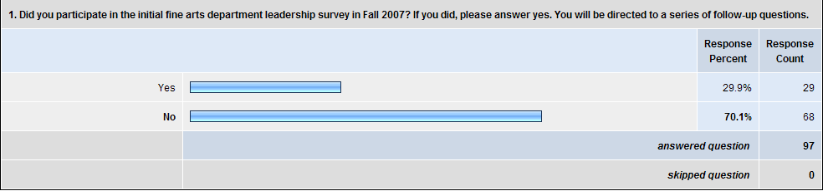
The second phase study began with this question intended to allow respondents who took the survey at the beginning of the year to only answer the new questions at the end of the survey. I was concerned over the length of the survey and wanted to make sure that returning respondents did not feel that they were participating in a redundant study. I did however want the feedback on the original questions from new respondents. Looking at the responses, both decisions seemed to be wise. I was pleased to have 29 respondents return to take the follow-up portion of the survey, yet I certainly needed the demographic and initial qualitative responses from new respondents to inform their answers to the end of the survey. The length of the survey also became a factor, with a high rate of attrition occurring in the respondents completing the entire survey at this time. The skip logic allowed at least the returning respondents to get to the new questions while still “fresh”.
The pilot and second phase studies will be analyzed side-by-side on questions that were the same in both studies. Since the skip logic limited each person to only completing these sections once, the data does not reflect any duplicate responses.

Demographics – Pilot and Second Phase Studies
The first section of questions focused purely on demographic information. The reason for including these questions was to judge the context of the qualitative information. It was important to get information from teachers of many of the arts disciplines, across all grade levels, with varying degrees of experience, and actual experience in dedicated fine arts departments. Without all of these factors present, the qualitative data would not be representative of the departmental situation I wished to analyze.
The results of each of these questions are presented in chart form with comments and analysis following each.
Pilot Study:

Second Phase Study:
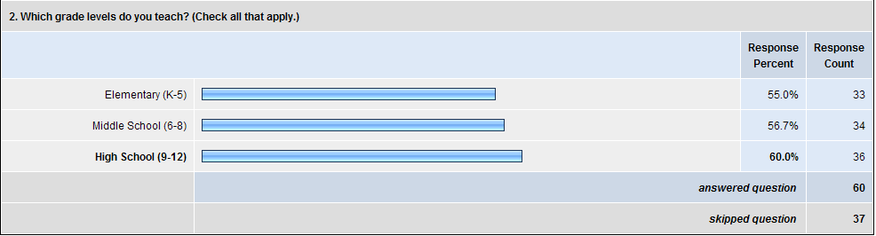
Respondents had the ability to select more than one level. Since independent schools often teach many grade levels, it is very common for teachers to teach a combination of the three levels. Middle and high school teachers were very likely to teach across both levels. Fine arts departments in these independent schools seem very likely to have teachers from all three grade levels in the same department. This is quite unusual when compared to the academic departments which may include middle and high school, but rarely include elementary teachers who teach in a multi-subject classroom environment.
The skipped question numbers on the second phase largely refer to the respondents who were part of the pilot study and were advanced past this portion of the survey by the initial skip logic.

Pilot Study:
Second Phase Study:
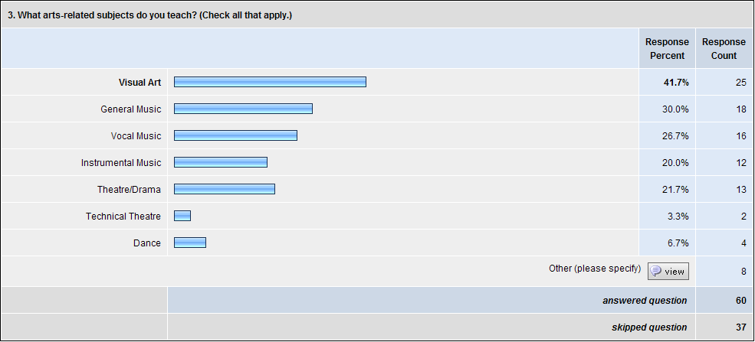
At first glance the survey seems dominated by visual arts teachers. But as visual arts are traditionally offered in most schools, it is reasonable to expect a large number of respondents from this area. The numbers from the other traditional areas (music and theatre) were strong. Respondents had the opportunity to provide alternative subject areas. Responses in this category included journalism, music theory, oral interpretation, advanced placement studio art, creative writing, and art history. All and all, these numbers reflect a good cross-section of fine arts teachers.
Pilot Study:
Second Phase Study:
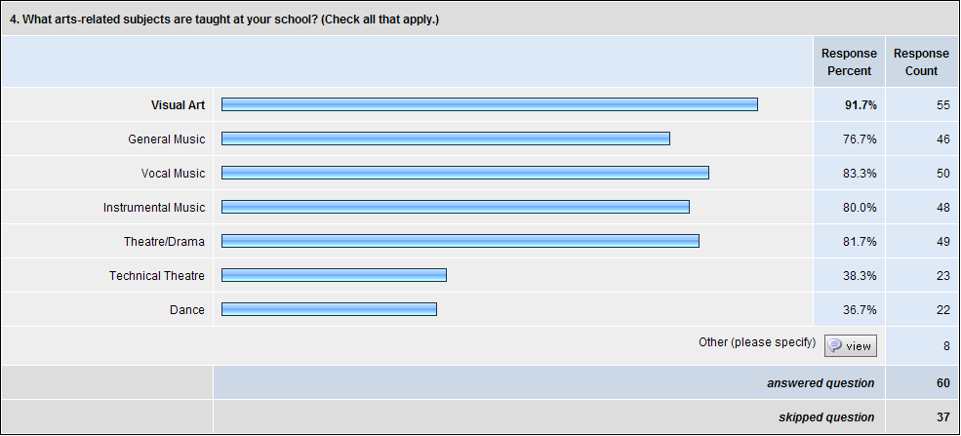
The departments represented by respondents generally contained a wide selection of arts courses, focused particularly on visual art, music, and theatre. Since I was particularly interested in how department heads lead diverse departments, this question shows that the respondents have diverse departments similar to my own. The dance number was higher than I expected, especially with only nine dance instructors combined responding to the surveys.
Pilot study:

Pilot study continued:

Second Phase Study:
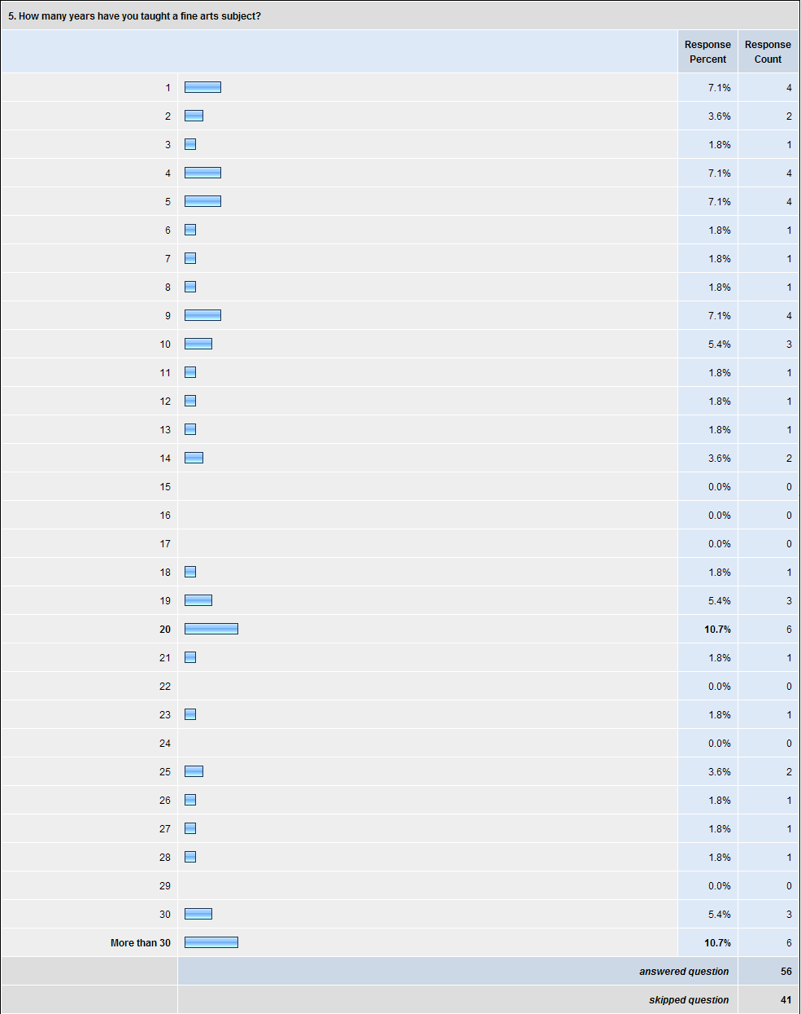
I was pleased to see a wide range of experience represented among the respondents. The data on the qualitative section of the survey would reflect the needs of both new and experienced teachers. Unfortunately, the national trend of educators leaving the profession within their first five to six years in the field may be partially reflected by this data, with a full third of respondents included in this experience range. There were however 14 respondents with more than 30 years of experience in arts education. While independent schools often lose experienced teachers to school systems and institutions with better pension plans, it was gratifying to see such a large number of career arts educators staying with their schools.
Pilot Study:
Second Phase Study:
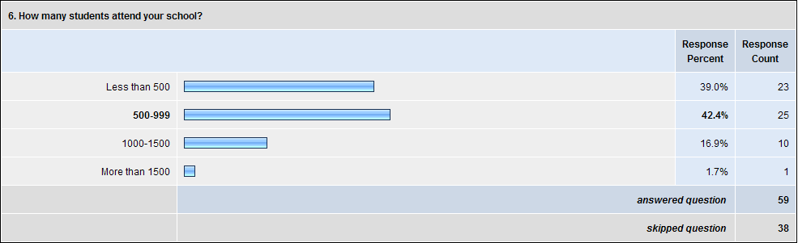
GISA member schools tend to be smaller, so this once again reflects an accurate cross-section of the schools surveyed. As may be expected, respondents from larger schools tended to have a wider variety of arts disciplines offered. My school has a population in the high 900s, so the data reflected by the respondents should be very applicable to my own situation.
Pilot Study:
Second Phase Study:
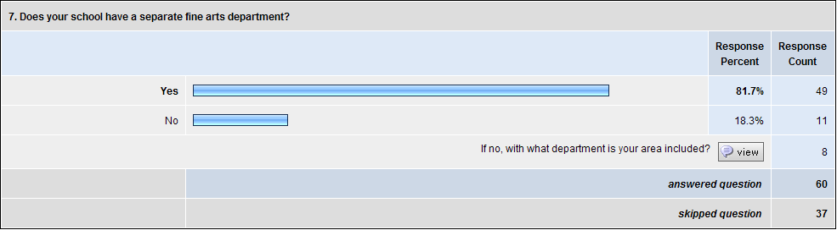
This question was very important to my data gathering. I wanted to know about needs and leadership of dedicated fine arts departments. If few respondents came from fine arts departments, the qualitative data would be considerably less useful. However, with over 79% of total respondents coming from a fine arts department, the data would seem to be quite relevant to the research question.
Most of the respondents who were not part of a fine arts department were included as part of a “Specials” department that would include such diverse extra-curricular subjects as art, music, physical education, library skills, and computer science. Since one of the largest challenges of leading a fine arts department is dealing with the inherent diversity of the subjects included in the department, the experiences of teachers in a Specials department should be quite valid to the intention of the study.
Pilot Study:

Second Phase Study:
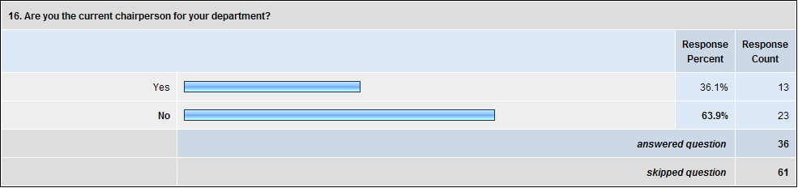
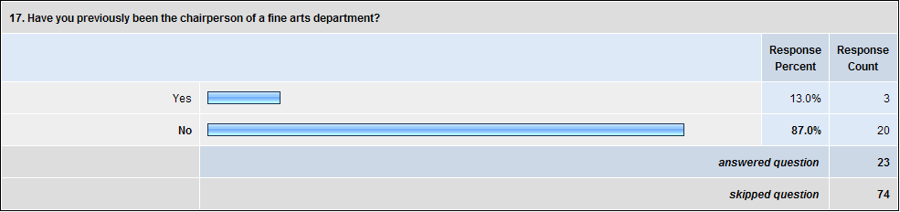
These two questions were posed later in the survey to target specific questions about fine arts leadership to current and former department heads. I was delighted to have 46 total respondents with department head experience to answer a separate series of questions.
In short, the demographic information established that the survey respondents reflected the required diversity to accurately address the research question.

Qualitative Questions Posed to All Respondents
Pilot Study:
Second Phase Study:
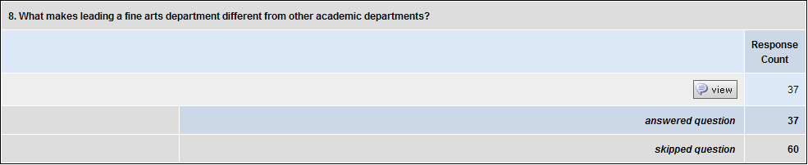
Several trends emerged from the answers to this question. Many respondents believed that fine arts departments were driven by creativity and allowed faculty members to work with students in unique ways. Fine arts teachers have the advantage of working with students over many years in situations in and out of the traditional classroom. They are less tied to rigid structure and have more freedom in planning curriculum. In general, the students who study in these courses want to be there and often develop a passion for the subject.
In the context of an independent school, respondents also discussed how arts teachers have the ability to teach over a larger age range than other teachers. The students a band teacher introduces to their instruments in 4th grade will be the same students leading the high school symphonic band years later. Teaching across so many grade levels requires flexibility and increased skill by the instructors.
Yet, the respondents relayed many specific difficulties. Most common was the failure of their programs to be recognized as vital by their school communities. The respondents are often forced to justify the need for their programs to exist, unlike traditional academic subjects. The support structures that exist for athletics are often missing for them as well. Money and time were also mentioned often as difficulties that are more acute in fine arts departments. These issues are especially prevalent with the numerous fine arts programs that exist outside of the regular school day.
Even the benefit of having students choose to be in an arts subject as opposed to it being required as a standard academic subject has a built-in difficulty. Arts teachers are forced to actively recruit students for their programs, sometimes having to compete with their colleagues in the department for enough students to make their particular program viable.
The inherent diversity of fine arts departments was mentioned frequently. Respondents were very aware of how different their artistic fields were from the others in the same department. This was reflected in the answers in both positive and negative lights: while the diversity energized the departments, it made leadership and coordinated efforts much more challenging.
Pilot Study:

Second Phase Study:
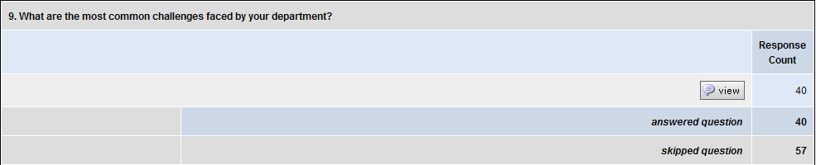
Most common challenges shared by respondents:
- Difficulty in scheduling. In independent schools, with fewer sections of classes, it can be quite difficult fit students into arts classes. Also, scheduling performances and other events against athletics proved a challenge for many respondents.
- Insufficient facilities and funding.
- Time. Arts require long periods of time to perfect – much of it outside of the classroom. Putting in these hours can be difficult, as can explaining to administrators and parents why they are vital.
- Competing with athletics and each other. To have an effective program, respondents felt a shared need to recruit. Often it would force them to recruit against athletics or even each other. Often a talented instrumentalist is also a talented singer. Supporting their departments while supporting their programs often became conflicting goals.
- Credibility. Respondents voiced the need to be taken seriously by other teachers, colleges (fine arts classes are often not averaged into grade point averages for college admittance evaluations), students, and parents.
- Grading. Putting a letter grade on a student’s performance in a fine arts class can be quite different from academic subjects. The process is considerably more subjective and can be difficult to explain to administrators and parents.
- Lack of full-time staff. Often fine arts teachers teach only part-time or have more traditional academic subjects to teach in addition to their arts duties. This can cause problems with planning and department cohesiveness.
- Collaboration. Often major art projects require leadership from several different teachers: e.g. the theatre, chorus, dance, and visual art teachers all needing to supply different parts of the presentation of a Broadway-style musical.
Pilot Study:
Second Phase Study:
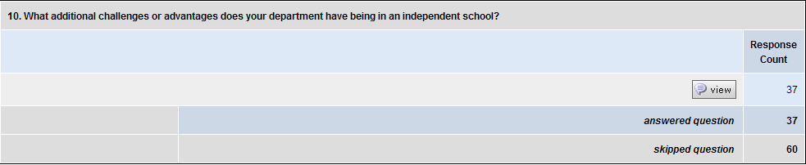
The most common advantage and disadvantage listed by respondents was money. Many respondents felt that being in an independent school gave them more money with which to work; a roughly equal number felt they had less money. Despite the large contrast in monetary support, many teachers agreed that independent schools provide a more nurturing environment for the arts with increased institutional freedoms. These freedoms are reflected in less bureaucracy, less rigid academic requirements, and easier access to policy makers.
Respondents also felt that independent schools provided a stronger base of parental support for arts programs. Since the parents are paying tuition to the school, they take more of an ownership stake in the success of the programs. Some respondents noted that this parental involvement can provide additional challenges as well with a large, vocal client-base to please.
The competition between arts and athletic, while seen in public and independent schools, was mentioned by respondents as being even more challenging in the private sector. Partly this is due to having a smaller student body to draw on for participation in programs. If 60 students from a male student body of 150 are part of the varsity football team, the arts programs will be hard-pressed to recruit boys during the fall months.
Pilot Study:
Second Phase Study:
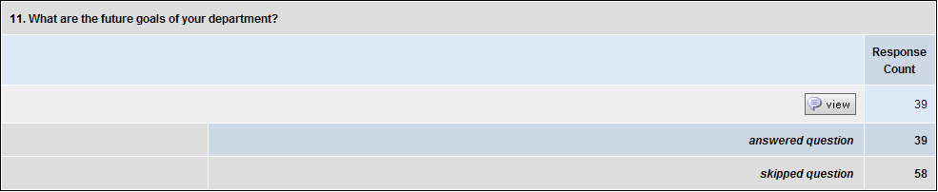
There were very consistent answers to this question. Most respondents hoped to improve arts facilities, expand course offerings, and/or increase student participation. Additional responses addressed the need to increase the acceptance of the arts into the culture of the school and improve visibility in the community.
Some teachers shared the goal of trying to explore the interdisciplinary powers of the arts, integrating their programs with the traditional academic subjects. Others took the connection between academics and arts another step, setting a goal of getting arts subjects treated as a full-fledged academic subjects by their schools.
Pilot Study:
Second Phase Study:
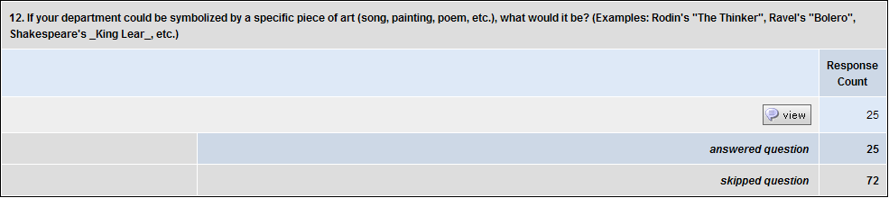
This is the first of several questions that asked for an artistic answer from respondents. The goal was to allow the teachers to respond more naturally to the question as artists. As was expected, many respondents chose not to answer this question or wrote that they were unsure of how to answer. Many, however, gave intriguing responses. The major trend that emerged among respondents feeling positive about their department was of artwork that involved many different parts or media: a symbol of the diversity of the fine arts department. Those with reservations about their departments replied with answers such as Shakespeare’s The Comedy of Errors and Ellison’s The Invisible Man. One respondent even said that their fine arts department digitally added their photos to Munch’s “The Scream” for the school yearbook. Songs referring to love and happiness were also a trend with “What I Did for Love”, “Ode to Joy”, and “All I Need is Love” making the list.
Three responses from the Second Phase study were particularly interesting:
From the whimsical:
- “I must definitely choose Beethoven's “Moonlight Sonata” because almost everything we do is after school and into the night.”
To the insightful:
- “Any music in Rondo form. I say this because it encompasses the diversity of the individual team members but the music always returns to the “A” theme which I think represents our oneness of purpose.
- “Dvorak's “New World Symphony” epitomizes our department. It is a forging of the old with the new. It is a celebration of traditional arts with a blend of modern/contemporary arts. It is setting the “new world” of arts on the map anticipating and celebrating the discoveries of the students as well as colleagues, parents, and administrators. Welcome to the “New World” of arts education!!! :)”

Pilot Study:
Second Phase Study:
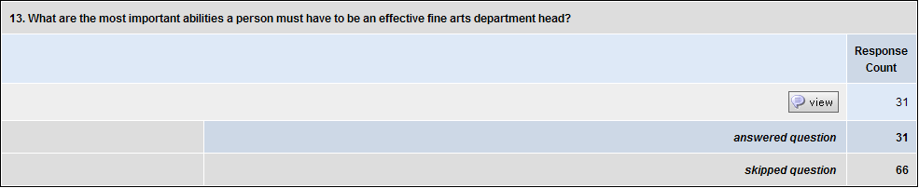
Several abilities dominated the responses to this question including creativity, organization, being a good listener, flexibility, and possessing an understanding and passion for all of the arts. Respondents believed that the department head has to have the ability to develop long-range plans while actively managing current projects. The department head should be a great communicator that possesses the ability to talk to diverse groups of people (artists and administrators) in their own languages. Endless patience, unswerving dedication to the department, and tenacity were also given as vital parts of a department head along with the ability to be friendly and approachable to all.
The responses to this question reminded me forcefully of the Winona State University study quoted by Bowman where a committee put together so many requirements for their department head that no person felt capable of filling the role. (Bowman, 2002)

Pilot Study:
Second Phase Study:
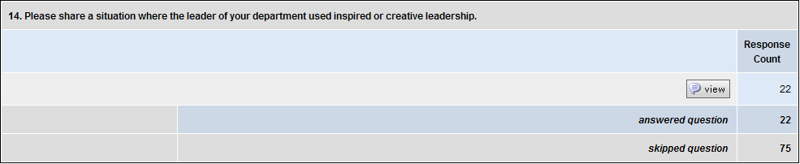
This was by far the least successful question, with very few responses and most of those of a rather limited nature. Of the respondents who offered specific incidents, most mentioned times when the department head initiated an arts project that used the talents of the entire fine arts faculty. In some cases this was a large-scale performance project, in others it was an in-service exercise designed for team-building and professional growth.
Some strong examples were offered in the second phase study:
- “The department head organized a Fine Arts evening which included performances representing each discipline and grade level. There were many opinions as to which groups should participate and it took a lot of leadership to keep everyone happy and motivated.”
- “As our leader, I instituted a self-grading concept for all my visual art students. It worked beautifully and we have used it every semester since. I based it on James Lipton's questions for Actor's Studio guests.”
- “Working with the coaches to allow the athletes to be in the spring musical at the same time as playing their spring sports.”
- “End of year assessment - the entire department made self-portrait dolls that allowed the creators to interpret their year through successes, failures, hopes and vision for upcoming year (personal and professional in all these respects) and then discussed the translations.”
- “Our department leader has come up with a Prism concert in which at the end of each year, we showcase what we have done in the past year. It really has brought to light many of our fine talents.”
- “I've just been named arts coordinator for next year: we did not have a department chair at all this year. (This is my first year at this school.) The first week of school, the drama teacher spoke with me about his desire to have a week dedicated to the Fine Arts, and how he's wished for this every year, “no one ever approves it”. So we took advantage of the fact that the music performances were scheduled Monday and Tuesday, put the Lower School World Celebration Day on Thursday, and the Spring Drama production on Friday and Saturday, lined up the Student Art show for that week, then threw in some creative writing displays and a sidewalk chalk festival, and voila--we had our Arts Week!”

Pilot Study:
Second Phase Study:
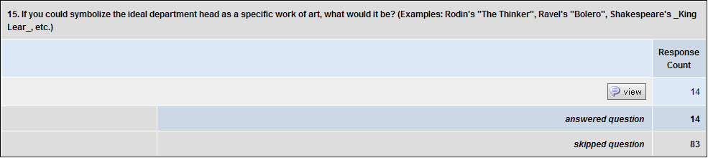
This question contained quite a diverse series of answers, with Shakespeare’s Prospero from The Tempest being mentioned more than once as well as Rodin’s “The Thinker”. “The Thinker” being an example in the question, however, probably inspired these answers.
In general, the artistic response questions seemed particularly hit and miss with respondents. Several respondents produced especially deep answers, while others remarked on the difficulty of answering the questions or of the level of annoyance they caused.
Some particularly thoughtful answers included:
- “Dolly in "Hello, Dolly" - a bit flashy, creative, slightly manipulative, and with a great big heart to see success in the children she teaches - all said, she should still work with integrity and genuine love for her students.”
- “Again, I must select a Beethoven piece – “Symphony No. 5.” Here we begin with a rousing beginning - one that calls attention to the department, but all the parts come together to make a great work.
- “Dave Brubeck Quartet's “Take Five” symbolizes an ideal department head. It has moments of structure paralleled with improvisation. It is a recognizable piece, yet heard live the improvisations change every time. You know what you are going to get, however there is always a creative bent to how you will get there – creativity with structure and control. All of the band members also have to share solos. Each one is heard for the same amount of time. Each has equal importance in keeping the music going. Yet, there is a main leader who brings everyone together in the end.”
- “KING KONG BIG, LOUD, VISIBLE, BUT......Deeply sensitive, gentle, inquisitive and able to love.....”
Other answers included the ever-popular “The Scream” by Edvard Munch and several works by Leonardo da Vinci.

Qualitative Questions Posed to Department Heads, Current and Former
Using skip logic based on the initial demographic questions, respondents with experience as a department head were given an additional set of questions.
Pilot Study:
Second Phase Study:
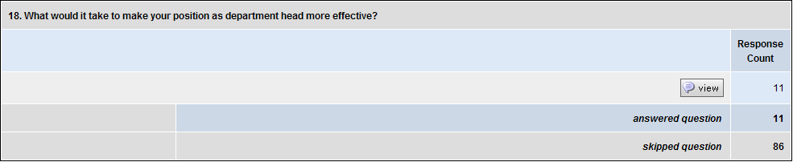
Dominating the answers to this question were better communication with administration, improved facilities and staffing, more formal time for department meetings, and more time with faculty and less time spent on administrative tasks. Several respondents stated the need for an administrative assistant to ease the load of paperwork and other requirements. Additional needs included better organizational connections between lower, middle, and upper school faculties.
An interesting conflicting opinion arose out of contact time during the school day with students. Some respondents were reluctant to lose time with students to concentrate on administrative tasks while others bemoaned the challenges of teaching five classes while dealing with the never-ending demands of leading a department. This seems to be a common theme across many of the questions: how does a department head function efficiently as an educator, artist, and administrator within the inherent time constraints of the school day.
Pilot Study:
Second Phase Study:
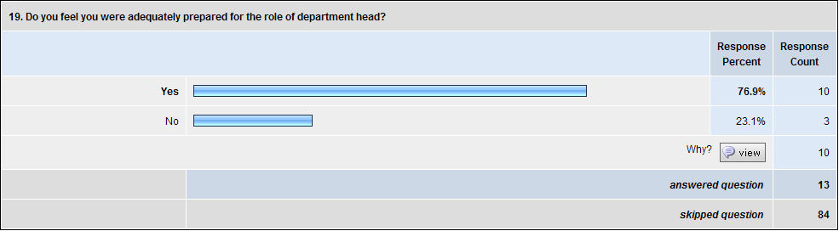
This is one of the few questions where the answers difference significantly from the pilot study to the second phase study. While the majority of respondents to both studies felt prepared to be department head, the second phase respondents had a much higher percentage with this feeling. This statistic difference could be reflected in the timing of the surveys: the pilot study included several first-time department heads just starting their service at the beginning of the school year. The second phase study was conducted during the last few weeks of the school year. The respondents to that survey had just completed a year in the leadership role and may have viewed their level of preparation accordingly. While I did not participate in either survey, I know that I personally would have said that I was not prepared at the beginning of the year, but would have felt quite differently after a successful school term.
The respondents who felt prepared generally came into the position after many years of teaching and even more years in the arts. They felt that their training and many years following examples of good leadership prepared them well for the task. Some respondents believed that their day-to-roles as parents provided leadership skills that translated well to being department head. Many teachers also mentioned higher-level college degrees that aided in their preparation to assume a leadership role.
Those that did not feel prepared mentioned lack of knowledge of the other areas of fine arts, no formal leadership training, and being put into the position too early in their teaching careers.
Pilot Study:

Second Phase Study:
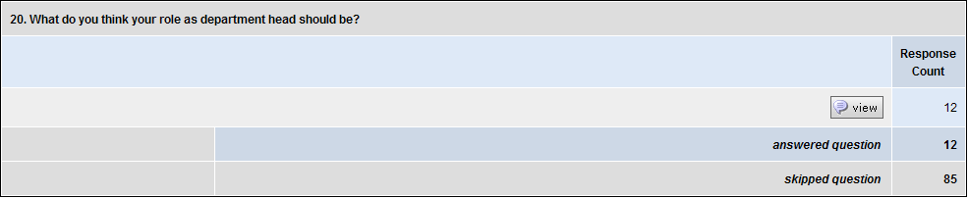
Many respondents felt they should be an advocate for arts on campus in general and for their fine arts teachers in particular. Some teachers took this advocacy another step, stating that fine arts department heads should also be seen as leaders of the arts within the broader community surrounding the school. Several mentioned the vital tasks of being an encourager and cheerleader for the teachers in the department. Also considered important was being a liaison between arts teachers and administrators.
Pilot Study:
Second Phase Study:
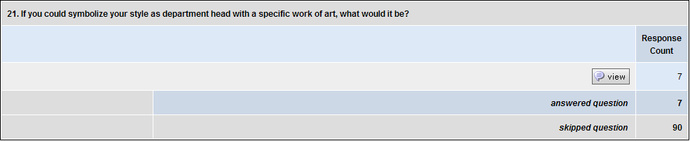
The final artistic response question provided a few thought-provoking answers. The following examples are taken from the surveys:
- “M.C. Escher's "Drawing Hands" is a great artwork because our department continuously draws in from one another for input on various issues, curriculum, and or concerns. All three of us also have a lot of experience in drawing and painting as well.”
- “Ives, 'Putnam's Camp' from 'Three Places in New England'... There are so many things going on at one time. I try to work with them all successfully.”
- “Mark Rothko----quietly, yet powerfully present”
- “An impressionistic painting The true work of art is most well understood from afar, making the individual brushstrokes secondary to the final work of art. The efforts of each individual work together to produce a final product in which all players are satisfied with their efforts and the community is pleased with the product.”
- “A photo-mosaic. Where many tiny pictures create a whole that can only be seen from far away. The pictures don't lose any of their integrity, but together, they can make something far grander.”
- “Abstract like Picasso, simple as Matisse, bright and colorful like Lichtenstein.”
- “The Geranium on the Window Sill Just Died, but Teacher You Went Right On” by Albert Cullum.

Qualitative Question Posed to Non-Department Heads
Respondents without department head experience were asked the following question:
Pilot Study:
Second Phase Study:
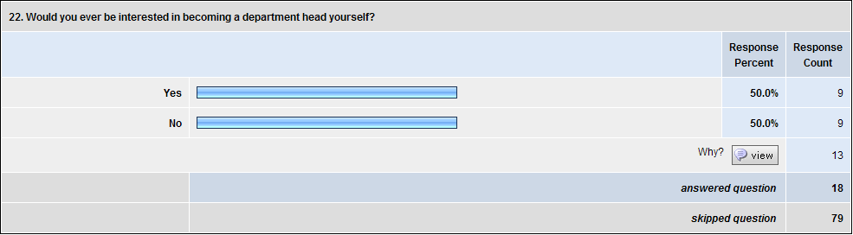
The majority of respondents answering “no” feared that becoming department head would take too much time away from their true love: working and teaching in their personal artistic discipline. Others feared that the increased responsibilities would be overwhelming for them or that they still lacked the skills necessary to be effective.
Examples of voices from those answering “no”:
- “I'd have to give up teaching one of my classes and then the students would suffer. Not because I couldn't teach them, but because the class offering wouldn't be there.”
- “I think it would be a big administrative headache.”
- “There is a possibility that I would love to have a leadership role in my department. However, I would like to oversee music education and not all fine arts education.”
Those answering “yes” mentioned having a love for the arts, a knowledge of many disciplines, and the desire to serve others through leadership.
Some voices of the respondents interested in assuming a leadership role included:
- “I would like to be the support that my fellow fine arts faculty need. I am very willing to push for what the arts program may need. I have a passion for making sure the arts are well represented and continue to grow.”
- “I respect that everyone has their own viewpoint or “constituency” that must be respected when trying to persuade or build consensus. I also think I have the ability to listen to ideas without becoming defensive that even the suggestion of a new idea is a criticism of what is in place. Also, I don't believe in micromanaging.”
- “Because of my many years of experience – I could mentor others.”
Questions Posed Only in the Second Phase Study
As stated in the methods section, the major intent of the second phase study was to take several of the challenges of leading fine arts departments suggested by respondents to the pilot study and exploring them more deeply. In the interest of focusing the answers more clearly, I chose only five of the major challenges to be the center of this portion of the study: communication difficulties, insufficient resources/funding, insufficient facilities, coping with being both an artist and an educator, and helping the fine arts find a voice in the school community. The five challenges were chosen not only because they were mentioned by many of the respondents but also because I feel that I face all of those challenges in my own department. It was important for the action research I was undertaking to address my own needs, to answer the questions I myself have about leading a fine arts department.
The data from these five sections was analyzed using a different method. An artistic inquiry was used, converting the survey data into a theatrical performance piece. Creating the script for this performance forced me to look very critically at the data and make connections between answers. The actual words of the respondents were used in many places bringing their individual voices to the forefront of the analysis. I discovered as I experimented with different methods of presenting the data that I became closer to the information, more personally connected to the challenges faced by the respondents. Clear, concise themes emerged from each of the series of challenge questions.
Initially I had planned to create individual performance pieces to represent each of the specific challenges. As I experimented with performing the data, it became very clear that the answers from the various question groups were intrinsically linked. Performing them as separately themed pieces would weaken that connection. I searched for a theme that would allow all of the sections to be represented as small pieces of a thematic whole: a reflection of their place in the lives of the respondents.
A chance comment from a respondent that a fine arts department is sometimes like a circus provided the final clue to the artistic analysis. I looked for ways to represent each challenge as an act at a circus. The acts would be introduced and connected by a ringmaster, a central symbol of the fine arts leader. I decided at this point that the other data from the survey would need to be included in the performance as well, setting up the basic structure of a fine arts department and introducing the five major challenges that were determined through the pilot study. This format would not only allow for an analysis that connected the two separate phases of the study, it would also allow me to clearly present my methodology to an audience along with my findings and analysis.
The final performance piece was created through a series of improvisations based on the coded data. After numerous attempts and hours of experimentation, a coherent performance piece emerged. Costumes, scenery, and music were added to promote the storytelling aspect of the piece and to draw audiences into the data. The final section of the performance piece, now titled The Cirque du F.A. was written to actually be performed by audience members, to draw them on-the-spot into the data analysis and presentation.
The Cirque du F.A. was performed on August 9, 2008, for an audience that included respondents to the survey, thesis advisor Dr. Michael McCarthy, and members of my Ed.S. cohort. Since the performance was created through improvisation and did not use an exact script, a transcript of that performance was converted into a script for this portion of the study. While the written form does not convey all of the meaning and power of the shared experience of the live performance, it does present my analysis of the data and gives voice to the responses of my survey participants.
Before the script, I have included graphs of the respondents’ answers to the “specific challenges to the fine arts” section. Each challenge’s section begins with a quantitative question designed to determine whether the issue was as large a concern to the second phase study respondents as it was to the pilot study respondents. I hoped for at least 25% of respondents to feel that it was an issue in their school to provide a strong pool of information. Respondents who did not encounter the problem at their school were skipped to the next question without being shown the follow-up questions analyzing that particular challenge.
The follow-up questions asked respondents to explain how the challenge manifested itself at their schools and the steps taken to overcome them. Each section finished with two questions that asked respondents to gauge whether or not the difficulty was improving at their school.

Fine Arts Challenge 1:
Problems with Communication Both within the Department
and Between the Department and the Rest of the School.
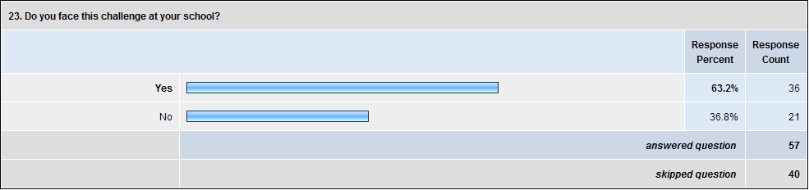

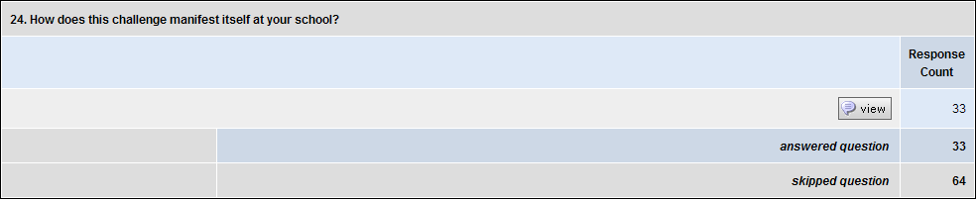

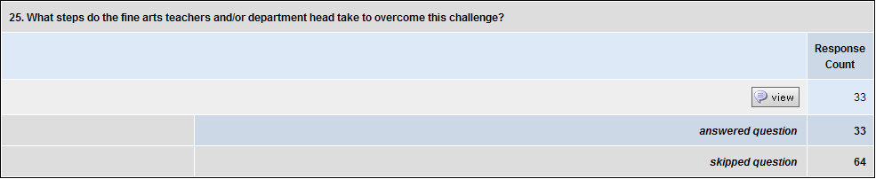

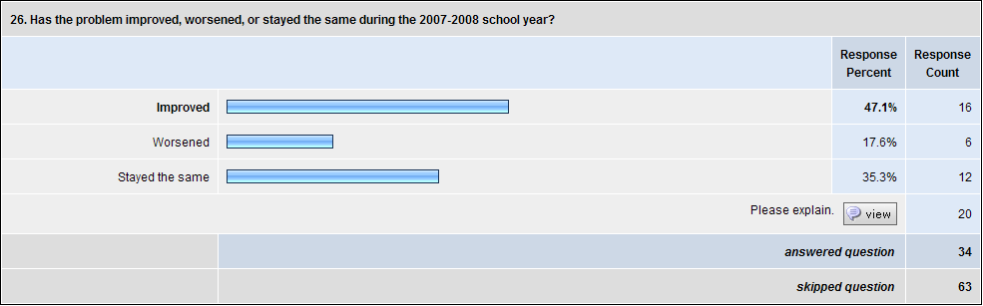

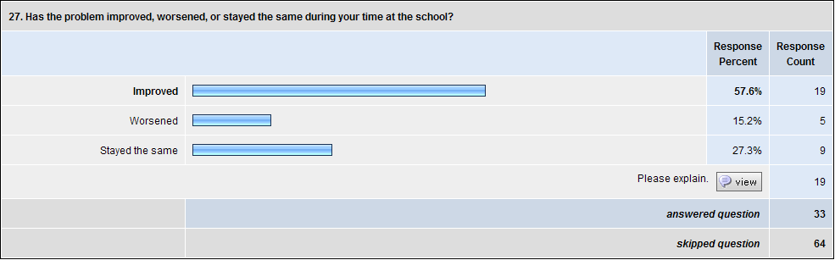

Fine Arts Challenge 2:
Insufficient Resources and/or Funding to Create Strong Arts Programs
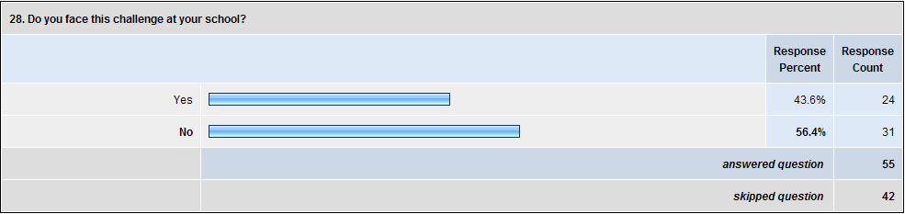

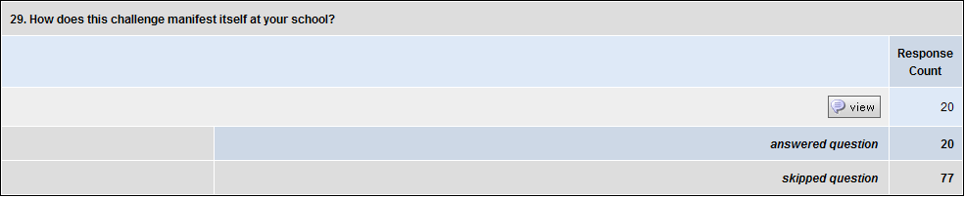

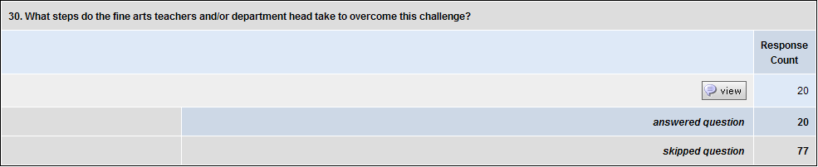

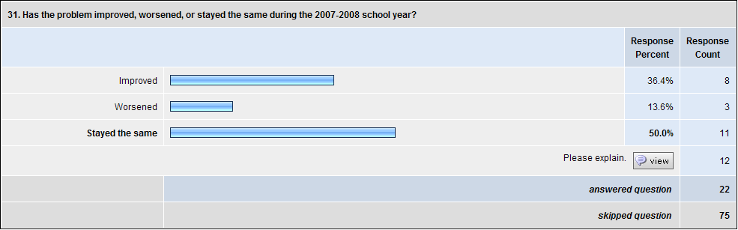

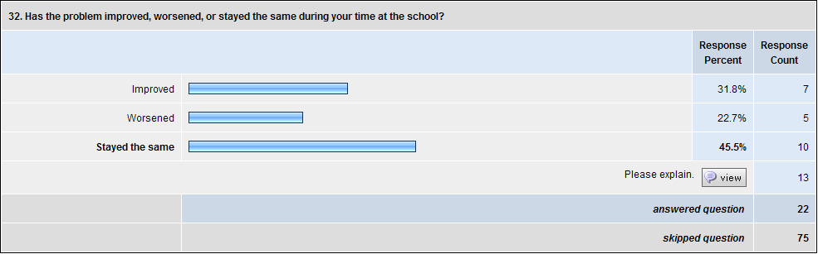

Fine Arts Challenge 3:
Insufficient Facilities, Especially a Lack of Dedicated Spaces for the Fine Arts
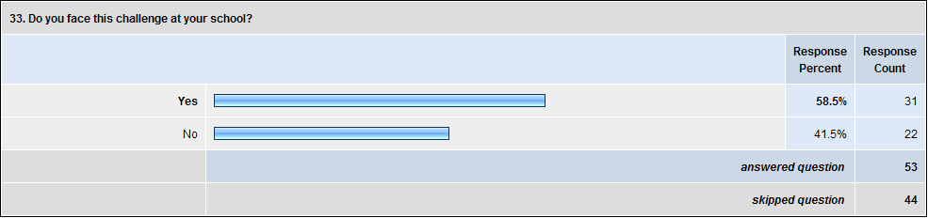

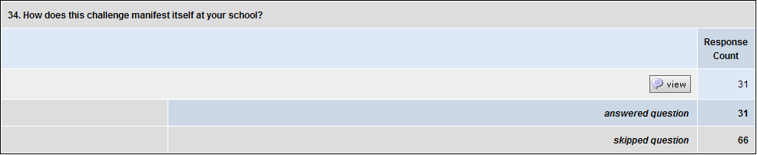

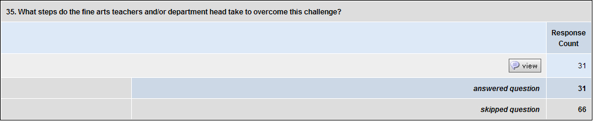

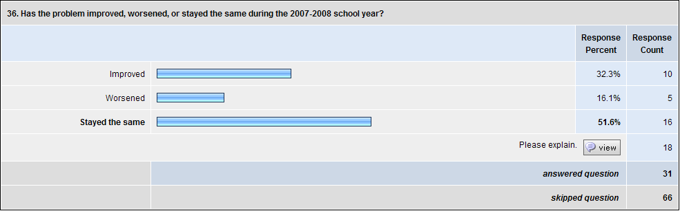

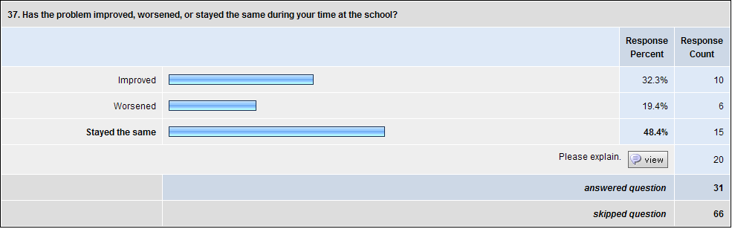

Fine Arts Challenge 4:
Coping with the Inherent Dichotomy of Teaching Fine Arts: Being Both an Artist and an Educator, Dealing with Creating Wonderful Art while Keeping Up with Administrative Tasks

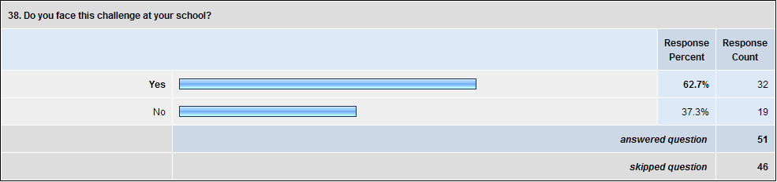

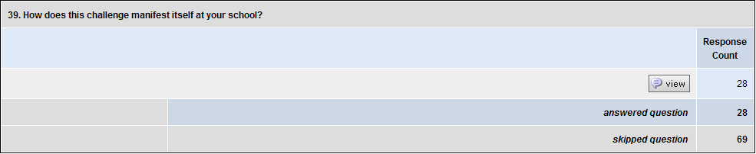

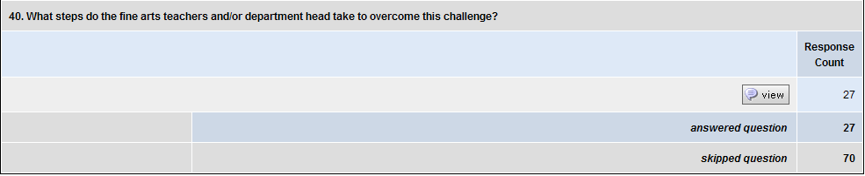

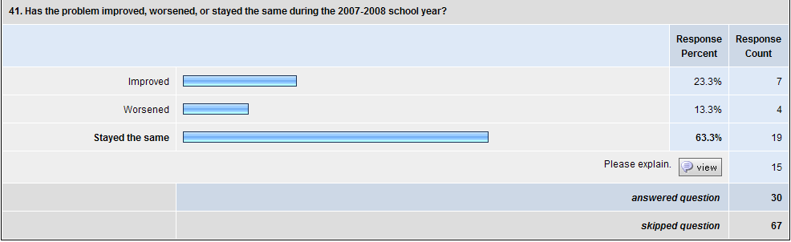

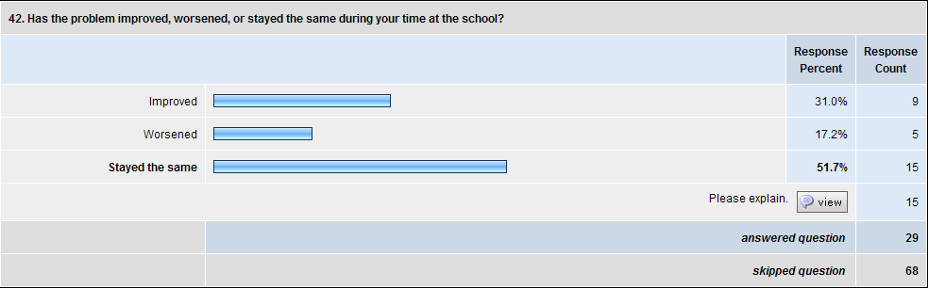

Fine Arts Challenge 5:
Helping the Fine Arts Find a Voice in the School and Community
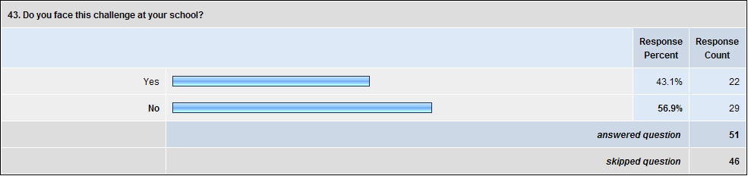
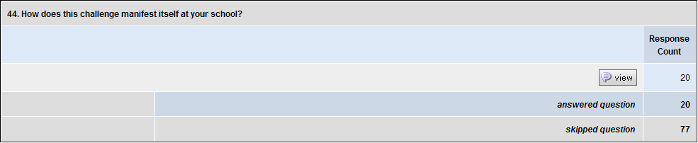
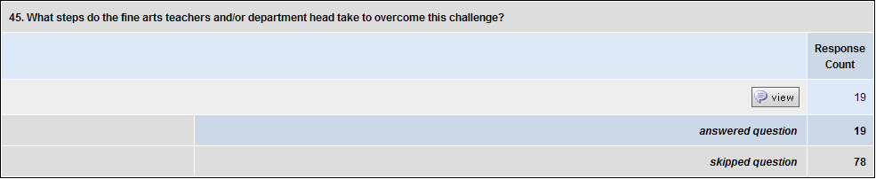
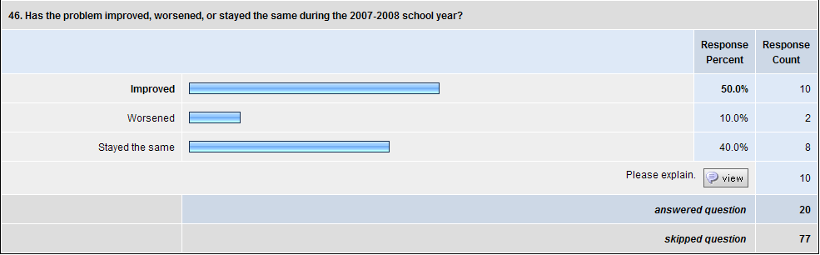
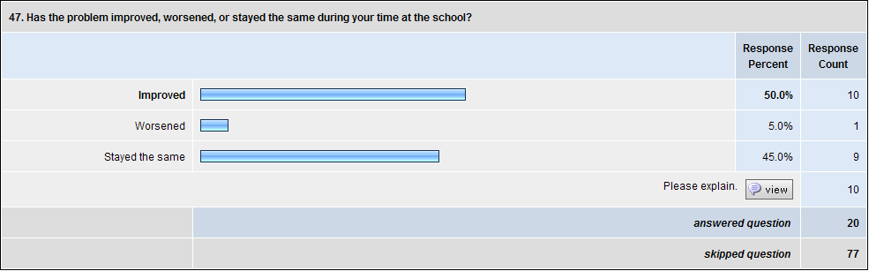
Artistic Analysis

The Cirque du F.A.
the circus of the fine arts

[The stage is set with five music stands, positioned as if for an orchestra and conductor. A free-standing shoji screen is upstage, lighted in various colors from behind. A silver mask hangs on the top of this screen, glowing from a light within. Long pashamina scarves of different colors hang down the hinged corners of the shoji and on each music stand. Three scarves hang from the center conductor’s stand.

All characters in the production are played by a single performer, morphing from one role to another with only a small costume change – an added jacket, vest, etc – and a change of voice and mannerisms.

Music from the Cirque du Soleil production of La Nouba plays throughout the show. For this scene it is the title track “La Nouba”.

The performer enters costumed as a RINGMASTER. He wears a long coat and stylized make-up. The RINGMASTER addresses the audience with a vaguely Italian accent and a great amount of bon ami. ]

RINGMASTER
Good evening, ladies and gentlemen, and welcome to my fabulous Cirque du F.A. – the circus of the fine arts. Yes, the fine arts department can often be like a circus: lots of things going on at one time, lots of beautiful art, but sometimes just an inch away from chaos. Ah, but I was not always the confident ringmaster you now see before you. No, no! I was scared; I had no idea what I was doing, so I did one of the few smart things in my life. I contacted people who had done it before: ringmasters, artists – all over the state of Georgia – and they gave me good ideas. Over 150 people answered the questions I had: what are the common parts of a fine arts department, what are the challenges they face, and most importantly how do I overcome them; what skills am I going to need to be the ringmaster for such a fabulous circus? Now that I have the answers, I have created the Cirque du F.A. to give you an idea of what I found. But before we begin, let’s turn it over to our fabulous – if slightly dysfunctional – orchestra. Maestro!

[The RINGMASTER exits to change into a black tuxedo coat. The next section – A Concerto for Five Stands – is performed entirely in pantomime, accompanied with music.

Five music stands are set up on the stage. One is positioned as if for a conductor in the center with the others arranged on either side. All characters in this musical pantomime will be played by one actor with no costume changes. The characters will be represented by the five music stands when not being enacted by the performer. There are no props used other than the stands.

The first character – the CONDUCTOR – walks in, obviously the man in charge. He looks around at the other stands, removes his baton from a pocket, steps to the center stand, and conducts a large upbeat. The music begins – George Gershwin’s “Concerto in F.”.

The CONDUCTOR directs the first measures of the music. He is obviously not pleased with what he hears. He conducts more forcefully, finally getting so frustrated that he is forced to cut off the orchestra (the music continues.) He angrily berates each stand (representing the other musicians.) There is obviously much animosity in the conversations. The CONDUCTOR is not listening nor trying to truly connect with the musicians. The CONDUCTOR conducts the orchestra in again, gets even more upset, cuts off the musicians, and proceeds to harangue them even more. Ultimately, the CONDUCTOR is so angered by some of the responses that he is getting back that he throws down his baton and stalks offstage, not to be seen again.

The performer re-enters and moves to one of the musician stands. He is now in the role of the VISUAL ARTIST. The ARTIST sneers at where the CONDUCTOR exited and waves his hand dismissively. He then turns his attention back to his work.

The ARTIST is hard at work painting on an invisible canvas. He reaches down to the stand and picks up an invisible jar of paint, opens it, and continues to paint with elaborate strokes. Eventually he puts down the jar of paint and reaches for another. He opens it and begins to paint without looking into the jar. He is shocked when no paint is appearing on the canvas. After examining the jar he realizes that it is empty. He is out of paint, unable to continue his work. The ARTIST deals with this set-back by pouting.

The performer walks upstage and turns his back on the audience, signifying a character change. After a beat, he walks to another stand. He is now the DANCER.

The DANCER performs a series of graceful dance moves. These moves are obviously hindered by the extremely small space in which he is performing. He tries gamely to dance but finally bumps into the stand hard, injuring himself. The DANCER stops dancing, nurses his wound, and cries.

Again the performer walks upstage and shifts into a different character. He moves to yet another stand, this time taking on the role of the SINGER.

The SINGER positions himself behind the music stand, treating it as if it was a microphone on a stand. He throws himself into a song but stops abruptly when he realizes that the audience cannot hear him. He mouths “Is this on?” while tapping on the invisible microphone. He tries to sing again with the same results. Disheartened by his inability to be heard by the audience, the SINGER stops singing.

Yet again, the performer shifts into another role: the ACTOR.

The ACTOR moves to the final stand and takes an invisible skull from off of it. He proceeds to pantomime a performance of the graveyard scene from Hamlet, complete with huge gestures and facial expressions. As he is just getting really into his performance, he notices someone else coming into the room. He moves center stage to talk to this person, who seems to be a colleague. The ACTOR is being asked to sign papers or complete some other paperwork. He takes out a pen and signs the documents genially, hands them back, and says goodbye to his visitor. He returns to his stand, taking a moment to remember what he was doing before being interrupted. He finally remembers and begins performing another piece, perhaps the balcony scene from Romeo and Juliet. Once again he is interrupted. After going through the routine of signing more papers, the ACTOR returns to his stand. This time however he is unable to continue his work, taken out of his art by the distractions.

The ACTOR suddenly hears the other musicians speaking to him. They are asking him to come to the conductor’s stand and lead the orchestra. The ACTOR refuses, feeling more comfortable behind his own stand, but eventually is convinced to come to the center stand. He picks up the discarded baton and gives it an experimental wave or two. He looks at the other stands with a “here goes nothing” look and gives the orchestra a big upbeat.

Sadly, the ACTOR has the same luck as the CONDUCTOR. The music sounds horrible, and the ACTOR is forced to cut off the orchestra. Instead of shouting at the musicians, however, he goes to each of them to find out what problems they are having.

When the ACTOR realizes that the ARTIST is out of paint, he finds a jar of paint near the center stand and gives it to the ARTIST. The ACTOR moves on to the DANCER and helps him by moving the DANCER’s stand far off to the side. A quick visit to the SINGER reveals the problem with the dysfunctional microphone. The ACTOR traces to microphone cord to the amplifier and realizes that it is not plugged in. He connects the microphone properly and returns to the center stand.

The performer then quickly performs the ARTIST, DANCER, and SINGER in their positions. All of the three characters are thrilled with the solutions to their problems and respond happily to the center stand.

The performer returns to the center stand and once more becomes the ACTOR. The ACTOR looks around at the other stands and gives them another giant upbeat. This time the music sounds wonderful. The ACTOR loses himself in the music, enjoying every moment of the experience. (“Concerto in F” stops playing at this point. The rest of the pantomime is performed in silence.) When the song ends, he cuts off the orchestra and congratulates each musician. He is overcome with happiness at their shared success.

Suddenly the ACTOR hears something offstage right. He goes over to accept congratulations on a wonderful performance. He basks in the praise, but quickly passes it along to the orchestra. Before they can really enjoy the accolades the unseen visitor hands the ACTOR a new piece of music. The ACTOR looks at it for a moment and then checks with the orchestra. They decide they can do even more, that they can learn a new piece of music together. The ACTOR takes the music to the center stand, ready to start conducting it, when he is called back by the visitor. The visitor gives the ACTOR more music, a huge stack that weighs him down. Gamely he lugs the stack of music back to the center stand and drops it on the floor. He looks at the stack tiredly, but heads behind the stand. He opens the next new piece of music, looks out at the other musicians, and shrugs comically. He gives a grand upbeat. The ACTOR freezes in this position, ending the pantomime.

The music changes to “A La Lune” from La Nouba as the performer exits the stage. He re-enters as the RINGMASTER. ]

RINGMASTER
Ah, yes…very talented, but as I said a wee bit dysfunctional. But in their way they have shown us important things: according to respondents the five major areas of the fine arts department: instrumental music, visual arts, dance, vocal music, and theatre. Unfortunately, they also showed us the five major challenges. (Gestures to the CONDUCTOR’s stand) Communication within and without the department. (Gestures to ARTIST’s stand) Insufficient funding, insufficient supplies. (Gestures to DANCER’s stand) Insufficient facilities. (Gestures to SINGER’s stand) Trouble finding a voice for the arts, connecting with the community about the importance of the arts. (Gestures to ACTOR’s stand) And the most common one of all according to the respondents: the difficulty in being both artist and educator at the same time and balancing both, being true to both. Now our performers at Cirque du F.A. are going to be addressing each of these. What better place to start than with the difficulty of being both educator and artist? And for that we bring on fabulous juggler extraordinaire Luigi! Luigi!

[RINGMASTER exits left and changes into JUGGLER. He re-enters wearing a colorful vest and carrying three juggling balls. He sets one ball on the ground and addresses the audience, speaking with a neutral American dialect. The music changes to “Distorted” from La Nouba.]

JUGGLER
Uh, Luigi always seemed so formal. Let’s just make it Lou. Okay?

[JUGGLER begins to juggle one ball, performing a fancy series of tosses, bounces, and grabs. He speaks throughout the juggling.]

You know, when I started this it was just me and my art. It was an amazing thing because it was just for me, and whatever I did was fine. It was as simple as I wanted it to be, exciting as I wanted it to be. It was pure and wonderful. But people started to watch it and liked what I did, so I starting doing a little more and a little more. And soon I got to the point where I thought wouldn’t it be great to be able to teach that to someone. And so I started to add another function. I started to add education.

[JUGGLER adds another ball to the routine. The difficulty of the juggling increases as he talks]

Well, now I’m teaching it and doing it and, you know, it was great. It was harder, and I made a lot more mistakes, but soon I found out that I could do all sorts of things that I couldn’t do with just one. And as long as I concentrate, I can do pretty much anything.

[JUGGLER begins juggling two balls with one hand, succeeding for a few passes before dropping the balls.]

But every now and then, with so much in the air, it falls. (He picks up the balls and continues.) Well, with any type of success, sooner or later someone gets the idea that you should probably be doing more. So something else gets added in.

[JUGGLER picks up the third ball and shows each ball in turn as he discusses the three facets of his professional life.]

So now I have my art, being an educator, and now trying to be a leader of other artists. So now all three have to stay in the air at one time.

[JUGGLER begins to perform the three-ball cascade. The balls promptly fall everywhere]

And when you try to do that things fall everywhere.

[JUGGLER picks up the balls and launches into a very successful three-ball cascade.]

The thing about juggling is the better you are at it, the easier it looks to everybody. You start adding in some tricks (He adds in a rainbow toss and catches the balls with a flourish) and still everyone says, “Oh, that’s wonderful, but you should be doing more.”

[JUGGLER gestures “excuse me a moment” to the audience and walks off right. He returns momentarily carrying the three juggling balls…and a concrete block. He moves to center and prepares to juggle.]

I’ll get back to you on this one.

[JUGGLER exits left. Performer changes back into RINGMASTER and enters to the sounds of “La Nouba”.]

RINGMASTER
Ah, Luigi, do not worry! You’ll get that block in the air one day. I put it there just for you after all! You’ll be able to do that just fine. (to audience) But that’s not the only problem we have. A big problem is finding a voice for the arts.

[RINGMASTER moves the four musician’s stands out of the acting area and relocates the CONDUCTOR’s stand upstage. ]

In the fine arts department we understand the challenge. We understand why it is important as many of you may certainly be realizing: how important the arts are. But sometimes in the community, past all the noise and all the other things that are there, it can be insanely difficult. For that we bring on “A Voice for the Arts”.

[RINGMASTER exits left to change into VOICE DANCER. The next section is danced to Cirque du Soleil music with pre-recorded quotations from study respondents mixed with it. The quotations are listed below in combination with a description of the dance performed by the VOICE DANCER.

The music begins. VOICE DANCER enters wearing all black. He stands left of the CONDUCTOR’s stand and radiates his arms and body towards the stand as if in reverence. He removes the purple scarf from the stand and moves to stage right, treating the scarf as if it is the embodiment of his art. He pretends to pull the scarf out of the ether and dances with it across the stage. The dance is graceful and loving, an artist and his art at peace together.]

RECORDED VOICE
The attitude that Arts activities are at the bottom of the priority list (1. academics, 2. sports) manifests itself when parents refuse to allow their child to attend a field trip performance to a musical because their child will miss one science class, or when a student does not attend the one combined rehearsal for the concert because he will miss one English class. My “favorite” question is: Do I have to come to the concert?

[VOICE DANCER moves to the center. Something is obviously wrong. He holds the scarf out to the full extent of his outstretched arms. With a grimace of pain he moves the scarf behind his back and ties it fiercely around his waist. VOICE DANCER reacts to the discomfort, but overcomes the difficulty to flow around stage right, back to the CONDUCTOR’s stand. Again he salutes the stand with reverence, drawing forth now the red scarf, another symbol of his art. ]

RECORDED VOICE
I find that there is a lack of knowledge or maybe it's just plain “jealousy” from my colleagues about what I do in fine arts. (pause)

Because I teach everybody, I know everybody, but not well – there is not the close rapport that students build with their classroom teachers. I also find it difficult to do the outreach that would make the program more visible outside the classroom. Also, the community is physically dispersed, not being based on a neighborhood, so figuring out a good community venue to display artwork has been a conundrum for me.

[VOICE DANCER dances with the red scarf across the stage, performing a more elaborate series of turns. The scarf is in constant motion, a partner to VOICE DANCER’s performance.]

RECORDED VOICE
Athletics is competition-based so there's always a score to report and a direct comparison made between 2 schools, naturally creating a voice in the school and outside the school. Fine Arts is all too often just within the school; we have to make an extra effort to reach outside of the school into the community.

[VOICE DANCER is drawn to the center of the stage. Again his relationship with his art is deteriorating. His inability to communicate to others is shown through the outstretched scarf moving behind his head and tightening cruelly to knot in his open mouth. VOICE DANCER is in great pain, but overcomes it once again. He flows back around left to center, still bound by the waist and mouth scarves.]

RECORDED VOICE
We are just a small percentage of the school population so it is difficult to get exposure. I don't want my group to have to battle for exposure. We need perhaps more opportunities for the kids to have more than one co-curricular class so more kids can be involved without needing to take the mandatory classes that interfere with our classes.

[VOICE DANCER draws forth the blue scarf leaving the stand bare. He dances with it again, his movements now expanding to a series of kicks and leaps. Yet the dance leads him to center once again.]

RECORDED VOICE
Fine Arts is not viewed as an essential part of the curriculum. Grades do not “count” towards students' overall averages. Arts classes are given last priority in planning and scheduling.

[VOICE DANCER struggles with the blue scarf, his hands thrust out towards the audience. With a series of arm pulses towards the audience, the scarf becomes more and more wrapped around VOICE DANCER’s wrists. When all the material has been wrapped, VOICE DANCER has his hands tied together in front of him. Yet he still tries to dance, thrusting his bound arms out in a series of dance steps towards each side of the stage.]

RECORDED VOICE
We struggle to get students to give the arts a chance, mostly, which could be helped by the administration setting different fine arts requirements for students (for example: only accepting a true fine arts class for a fine arts credit).

[VOICE DANCER moves back to center. His bound hands reach to the sky and then slowly move forward until they seem to entreat the audience.

RECORDED VOICE
We must overcome the view that the fine arts are unimportant

[VOICE DANCER releases his arms with a series of arm thrusts towards the audience. He stretches out the scarf and lets it fall.]

RECORDED VOICE
We must overcome the view that the fine arts are unimportant

[VOICE DANCER unties the scarf from around his waist, stretches it out, and lets it fall behind him.]

RECORDED VOICE
We must overcome the view that the fine arts are unimportant

[VOICE DANCER, with a final act of strength, unties the scarf gagging his mouth. He stretches the scarf to its full length behind him.]

VOICE DANCER
I need a voice.

[As the music ends, VOICE DANCER picks up the three scarves and exits right. The performer changes back into the RINGMASTER and enters as the music changes once again to “A La Lune”.]

RINGMASTER
Ah, we do need a voice. From where will that voice come? It won’t come from outside. It must come from the artist working on the inside. There’s another problem: a problem that’s not just in fine arts departments. Insufficient funding, insufficient facilities. Everyone faces that, but sometimes not as acutely as the fine arts department. To tell you about that we bring out Gunthat, the world’s greatest animal tamer!

[The performer exits left to change into the ANIMAL TAMER. The music segues into “Jardin Chinois” from La Nouba. The performer enters wearing a rugged vest and speaking now in a British dialect.]

ANIMAL TAMER
(confidently) Yes, ladies and gentlemen, please hold your applause. Oh, you already did. Yes, you are looking at the finest animal tamer in the entire world! And today, I am going to amaze you with my brilliant skill. (laughs nervously) Well, to be completely honest with you, actually I haven’t gotten a chance to rehearse in this space yet. Someone else always seems to be using it. But I found a corner to work in. I didn’t have my animals with me, but I got all my moves down. I have my art, I have my audience, and that’s all I really need…aside from a little equipment. You can’t tame an animal, a wild beast, without a whip and a chair! So forgetful…be right back.

[ANIMAL TAMER exits left and returns with a long, black whip. The whip is old and overused with a frayed end.]

You know, good equipment is essential for this whole thing. It could be the difference between life and death. A good whip can… (He examines the whip closely and laughs nervously.) Um, it’s a little old, seems to be fraying a little bit on the end. So do I for that matter, But it looks serviceable…if you kind of squint. Um, it should work for this. So I have a good…I have a whip. So I’m ready with that. Oh…the chair. You know, there’s nothing like a good chair for animal taming.

[ANIMAL TAMER exits off left and returns carrying a chair. It is comically tiny, barely larger than his hand. He looks at it disdainfully.]

And this is nothing like a good chair for animal training. But it’s what we have, and we’ll make it work! That is our motto: we’ll make it work! Okay!

[ANIMAL TAMER walks across the stage and begins preparing himself to face the wild beasts.]

I have my whip…and my chair. I am ready now for my assistant to release the mighty beast!

[ANIMAL TAMER strikes a mighty pose, bracing himself for the onslaught of what is sure to be a ferocious attack from the animal. The ASSISTANT sets a small toy Tigger doll on the far side of the stage. It looks painfully cute. The ANIMAL TAMER just looks in pain. He stares at the toy orange tiger in disbelief.]

That’s really quite disappointing. You see, the problem is that if you don’t have the equipment, you don’t have the materials, and you don’t have the facilities, sooner or later you might not have the people either.

[Thoroughly beaten, the ANIMAL TAMER exits left, taking the whip, chair, and toy tiger with him. He changes back into the RINGMASTER as the music changes back into “La Nouba”.]

RINGMASTER
(entering) Sorry about that last act, ladies and gentlemen. Do not worry, Gunthar, I will get you a tiger…someday, as soon as it’s in the budget. (to audience) Our final act. What would a circus be without a clown? Especially the Cirque du F.A.! In this case, it is the clown of communication. (exits)

[The music changes to “Propel” from La Nouba. The performer re-enters, dressed now as a traditional circus clown. The CLOWN strides to center and makes a big show of putting on a fireman’s helmet. He moves over to the side, takes off the hat, stretches, and falls asleep. As the CLOWN sleeps, smoke starts to fill the stage (from an offstage chemical haze machine). The CLOWN is jolted awake by the sound of a fire alarm (unheard by the audience). He quickly puts his hat back on and rides off to save the day. He pretends to be a fire truck, spinning his arm above his head to be the siren. When he arrives at the other side of the stage, the CLOWN reacts in comic shock to the smoke billowing all around him. He quickly locates a fire hose and attaches it to a hydrant with exaggerated motions. The CLOWN picks up the heavy hose and valiantly carries it to the other side of the stage, ready to fight the fire. When he tries to turn on the hose, nothing happens. The CLOWN fiddles with the nozzle of the hose and tries again. No water. He looks into the hose to see what the problem is only to be rewarded by a strong spray of water in the face. The fire helmet flies across the room. The CLOWN is frustrated but suddenly sees something. He walks to the edge of the stage, noticing that the ASSISTANT is smoking a cigarette. This is what is making all the smoke, not a fire! The CLOWN, greatly annoyed with the ASSISTANT, stomps offstage. He returns with a bucket. He stalks the ASSISTANT, finally dumping the contents of the bucket – hundreds of rose petals – all over him. Pointedly, the CLOWN confiscates the cigarette from the ASSISTANT, drops it in the bucket, and takes both offstage. The music flows into “Jardin Chinois”. The CLOWN returns and addresses the audience. ]

CLOWN
You know, I never expected to be a clown. When I started leading a fine arts department I had so many wonderful things to say. I could not wait to start putting those across to people. But, at first, all I ever seemed to do was put out fires. And the amazing thing was, often this huge amount of smoke – what seemed to be a huge fire – was caused by the smallest little thing.

[CLOWN walks over and pointedly glares at the ASSISTANT.]

And often, there got to be so much smoke because of lack of communication. Once I overcame that, then I found I had another issue. And that was…I had so much to say, I was trying to communicate it to people, but every time I would say something profound they wouldn’t take it seriously. They would think that we were just kind of…fluff. I would say something that I thought was important, and they would think it was funny. I felt like a clown. (He laughs nervously then is suddenly grave, his voice breaking slightly with emotion.) I felt..like a clown.

[The CLOWN exits quickly, fighting back tears of sadness, embarrassment, and shame. The performer changes into the RINGMASTER one last time. “A La Lune” plays again. The RINGMASTER wanders into the audience, with a “cigarette girl” style tray attached around his neck with a brown strap. The strap is made from one of the same scarves that cover the stage. The tray is filled with a variety of movie-sized candy.]

RINGMASTER
Get your chocolate bars! Get your peanuts! Get your Junior Mints! Cracker Jacks, get your Cracker Jacks! What? A problem with the ringmaster selling candy? You may not have noticed it, but we have a very small staff. And besides…we all have to be part of fundraising. (gesturing to the stage) Amazing thing…I have very, very talented artists, but they have a lot of problems…and they like to talk about them. So did my respondents. But this is not a bad thing. This is a good thing. It’s good to be able to share problems, and there’s comfort and there’s solace in knowing your problem is everyone else’s problem too. But the problem is that is not enough. Sooner or later you have to stop saying that this is a problem and look for a solution, eh? It’s like…good example: if you’re in a room with a lot of other people – say a boring faculty meeting. I know you’ve never been to one. I have. In the meeting let’s say everyone in the room is hungry – really, really hungry. Well, it’s not quite that bad if everyone is hungry, because you have plenty to talk about. Oh, I’m so hungry. When is it going to end? Where are you going to go? Do you want to get a burger? You always have something to talk about, and it’s better. But you’re still hungry. But it’s better. Sooner or later you have to stop saying I’m hungry and go get a sandwich. And that’s the point where I’m at. Thankfully, the 150 people who helped me as a young ringmaster also had some solutions, or possible solutions – beginnings to solutions – and they have shared those. I think it is very important to hear their voices. (gesturing to the stage) You’ve heard their voices included in parts of this, I want you to hear them now. I want to address each of these areas very quickly, and I am going to ask you to be their voices. So first, for communication, what’s better than Symphony chocolate bars? Symphony, eh? Clever Ringmaster.

[RINGMASTER passes out chocolate bars to three audience members. Each bar has a quotation from a respondent attached to it. The audience members read the quotations aloud.]

AUDIENCE READER 1
As the fine arts director I have held regular departmental meetings to foster cooperation within the department. I have also held regular meetings with the administration so that I may act as the liaison between the department and the administration.

AUDIENCE READER 2
We have a booster club for the fine arts, and they put out a newsletter. They also have funded various projects and spread their money between programs quite fairly. When it comes to publicity for any particular event or concert, it is still up to the teacher to get the word out.

AUDIENCE READER 3
We are enlisting the help of our parent organization to help educate our entire school population. We hope to post News in Arts Education on our web page, and begin each meeting with facts about how arts education contributes to the full education of a child.

We have a Fine Arts blog where people are recognized or can ask for help with situations. Fine Arts is represented on the upper school Academic Council.

RINGMASTER
For the insufficient financing, I thought peanuts seemed appropriate. That’s often what we get. Yes! You too, I’m sure. I hope you don’t have a nut allergy.

[RINGMASTER passes out boxes of chocolate-covered peanutes to three audience members. Each box has a quotation from a respondent attached to it. The audience members read the quotations aloud.]

AUDIENCE READER 4
Organizing fund raising, looking for grant opportunities, developing awareness in the school community of needs/potentials

AUDIENCE READER 5
We have to adapt and overcome. If we can not fire clay at our school, maybe at another school or facility. For this year we did a combination of air dried and non non-drying modeling clays.

AUDIENCE READER 6
We call in lots of favors to our fellow Fine Arts teachers to borrow equipment and ask for help. This has meant many hours of personal time in returning these favors.

The department head speaks often with the administrators that deal with budgets and financial issues and is very committed to showing them exactly why we need what we are requesting.

RINGMASTER
By the way, these are all guaranteed calorie-free – special fine arts candy. For facilities: Junior Mints because sometimes the arts are treated like junior citizens. Don’t worry, there’s plenty to go around.

[RINGMASTER passes out boxes of candy to three audience members. Each box has a quotation from a respondent attached to it. The audience members read the quotations aloud.]

AUDIENCE READER 7
We work closely with each other to make the most productive use of the space we have. We also work with the administration to find creative uses of space.

We are buying equipment to allow us to turn our gym into a “Black Box” theatre.

AUDIENCE READER 8
Trying to create awareness of needs in our program to past alumni, friends of our school who can give and donate to a good cause.

We have a wish list and we have direct communication with our higher ups to plead our request and cases to the board and see if we can put these issues either into immediate action or well thought out long range plans.

AUDIENCE READER 9
We are very flexible. We will meet our classes in any room with any available time. This often results in teachers meeting with students after school and on weekends, and students rehearsing in what are actually storage rooms. We do our best not to allow the lack of facilities to affect our students.

RINGMASTER
I love M&Ms. Part chocolate, part candy. Part artist, part educator. Ah, so clever. M&Ms?

[RINGMASTER passes out boxes of M&Ms to three audience members. Each box has a quotation from a respondent attached to it. The audience members read the quotations aloud.]

AUDIENCE READER 10
Be compliant with set expectations and do our jobs even if it means on our own personal time; our department prides itself in making what we do look easy while at the same time continuing to set the bar higher and higher each year

AUDIENCE READER 11
Encourage faculty to pursue their own art form. That is a necessary part of being a good teacher.

This year I applied for professional development for lessons, so that I can better my abilities for my own personal music growth and to better my classroom.

AUDIENCE READER 12
1. lead by example 2. stress to team how we are viewed when we're disorganized and how that lowers respect for what we do 3. stess to team how we need to function within the parameters of the school environment because that's where we are and that needs to be respected (I'm talking about things like playground duty, getting grades turned in on time, remembering to request performance spaces in writing, communicating with parents in a timely manner, etc...)

RINGMASTER
Cracker Jacks! Get your Cracker Jacks. You see, to bring a voice to the fine arts, you need a noisy snack.

[RINGMASTER passes out Cracker Jacks to three audience members. Each box has a quotation from a respondent attached to it. The audience members read the quotations aloud.]

AUDIENCE READER 13
We try to keep work on display, and regularly promote the work in school wide publications.

We desire excellence in our programs, talk to loyal parents about being arts advocates

We find special stories to catch attention

AUDIENCE READER 14
We try to create a quality experience--one that the child doesn't want to miss, and that the audience wants to see! I believe that as time goes on, the quality of the experience is what will change the attitudes--everyone likes to be a part of excellence, even though sometimes they don't want to do the work at first.

We are beginning a performing arts club next year; we hosted an Empty Bowls dinner this year to promote the arts and service learning; hope to host a school-wide art show next year as well

AUDIENCE READER 15
We are initiating an effort to communicate the importance of Arts education. We have a goal to include information on the benefits of Arts Education in all information sent home to our community: our web pages, handouts, parent organization information, etc... We do our best to communicate our needs to the school administrators and offer to get involved and help with class scheduling and other items. We do our best to offer solutions and not simply bring problems to the table.

[RINGMASTER takes off candy tray and sets it on the stage.]

RINGMASTER
I learned a lot of things from my colleagues. I learned what I need to do to be a better ringmaster, a better leader for my department. I have to spend time every day communicating with my department and with those people outside of the department. I have to look for every avenue possible to show everyone not only how important the arts are, but the amazing work that’s going on. I have to make those connections, and I have to be an advocate for the people who are doing this valuable work. (He grandly addresses the audience one last time.) Thank you so much for coming to the Cirque du F.A. today. Hopefully it will grow larger and larger, and we hope to see you again many times. Bon giorno.

[RINGMASTER exits as “Distorted” plays once again. Curtain.]

Additional Questions Posed to Second Phase Study Respondents
As I was creating the online version of the second phase survey, I decided to add three additional quantitative questions. While they did not connect directly to my goal of finding strategies to assist me in becoming a better fine arts leader, they were important to me in other ways. After reading the difficulties that teachers were facing in the pilot study, I felt a real connection with these other educators – even though they were anonymous in the study. I was curious whether or not they would be continuing in the field of arts education despite the difficulties they faced. Would they look for a new school, possibly heading to the public sector in search of better retirement benefits? Would they continue teaching outside of the fine arts? Would they assume the leadership of a department? My curiosity about my respondents, and in many ways my own yearly answers to these same issues, led to the following questions.
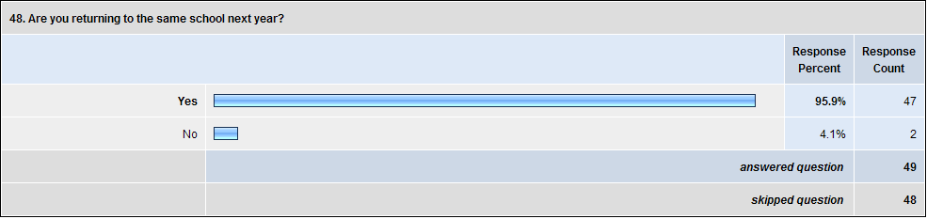
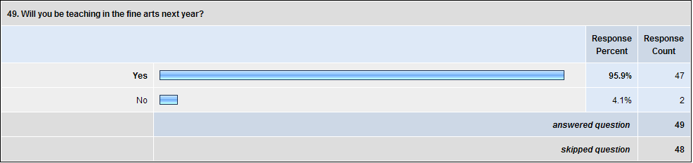

I was not only amazed by the high percentage of teachers returning to teach in the same positions next year, but was also emotionally moved. The fine arts apparently have an allure that holds on to the respondents in a powerful way. No wonder so many respondents wrote so passionately about the challenges they face. They have a vested interest and dedication to improving their teaching situations. I feel that I share these qualities with the respondents.

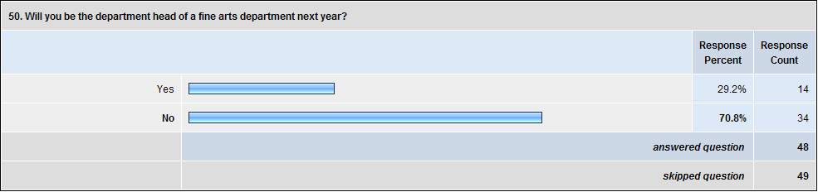

All of the respondents who were department heads during the 2007-2008 school year were returning to the same leadership role for the next year. In addition, one respondent was just assuming leadership of their department. I took it as a positive sign that so many teachers were continuing as department heads, undaunted by the challenges. I hope that I can follow their example.
Action Plan
While none of the solutions offered by respondents to the survey were a panacea for the problems facing fine arts departments, the willingness of fine arts educators to share their challenges, successes, solutions, and dreams suggests a course of action. Fine arts leaders need a forum in which to continue the work touched on so briefly in this study. A resource needs to be created that will allow leaders in all areas of fine arts education to share ideas and look for solutions together. The arts education organizations that exist are valuable, but have no central focus on leadership.
A fine arts leadership organization could be started as an online-only community, allowing leaders in arts education from across the country (and the world) a place to meet and discuss the issues that pertain to improving conditions in fine arts departments. This online group could evolve naturally into an organization with a face-to-face annual conference.
Over the next year, I plan to share The Cirque du F.A. artistic inquiry performance piece at numerous conferences around the country, including the Georgia Independent School Association that was the basis of this study. A professionally filmed version of the piece is also currently in production. This will allow the research to be seen by a larger audience. I will use these performances (both live and via the video) to promote discussion about issues facing fine arts departments and promote the development of an online leadership organization. I also plan to be a more active part of national arts education associations, both for my own betterment and to recruit help for bringing this online community to life.
On the local level, I am preparing to share The Cirque du F.A. with the administration and teachers at my school. In many ways, this is the much harder step for me. Convincing non-artists about the desperate needs of fine arts departments in general and my own in particular will be immensely challenging. I risk seeming like a complainer or someone who puts the importance of their department over everything else at the school. Yet the respondents to this study have made me feel how important it is to strive to find a voice for the arts. As the Ringmaster says in The Cirque du F.A.:
“Ah, we do need a voice. From where will that voice come? It won’t come from outside. It must come from the artist working on the inside.”
Conclusion
The information from this study is enormously useful to me. I tend to exist in the cave of my own theatre. I rarely get to see other schools or witness the dynamics of other departments. Through the respondents I discovered that the issues I face on my campus are quite similar to those faced by fine arts teachers across the state. The lesson is well learned. If other teachers’ experiences are similar, then their solutions will be helpful to me as well. I need to be prepared to reach out to the other teachers in the state and expand my own personal community of educators.
I also received valuable feedback on how arts teachers want to be led. I need to continue to review the responses to the leadership sections of the survey and use these to inform my approaches to First Presbyterian Day School’s fine arts department. Several of the teachers in my department completed the survey and shared their answers with me. These discussions have already helped me develop ideas for the future. The lines of communication that have been forged through the discussions are even more valuable to the future success of our department.
Personally, I have undergone major changes through my work on this project. I feel more connected to my work as an educator than ever before. I am leading my department with much more confidence. I feel that I now have colleagues in department leadership who are with me on the journey, that I am no longer the only reference point for the leadership of my department. More than anything, I respect even more the work of the teachers in my department and make it a point to learn from them every day.

References
Bagley, C. and Cancienne, M. ed. (2002). Dancing the Data. New York: Peter Lang Publishing.
Barylick, M. (2004). Three philosophical imperatives for an integrated arts program. Journal of
Dance Education, 4(4), 126-132. Retrieved August 14, 2007, from International Bibliography of Theatre & Dance with Full Text database.
Bates, J. (2006, Summer). Primary thoughts about teaching secondary school. Southern
Theatre, 47(3), 4. Retrieved August 14, 2007, from International Bibliography of Theatre & Dance with Full Text database.
Bell, L. (1992). Managing Teams in Secondary Schools. London: Routledge.
Bowman, R. (2002, January/February). The real work of department chair. The Clearing House,
75(3), 158-62.
Brick, P., J. Kerwin, K. Levin, D. Cantor, J. O’Brien, A. Wang, S. Campbell & S. Shipp (2004).
Comparison of web, mail, and mixed-mode data collection methods in a survey of R&D funding. Conference Papers -- 2004 Annual Meeting. Phoenix, AZ: American Association for Public Opinion Research.
Dozier, T. (2007, September). Turning good teachers into great leaders. Educational Leadership,
65(1), 54-58.
Ewell, M. (2006, Feburary). Creativity, faith and a stronger community. Retrieved February 28,
2008, from Community Arts Network Reading Room Web site: http://www.communityarts.net/readingroom/archivefiles/2006/08/creativity_fait.php
Freya, J. (2006, January). Cornerstone's faith-based theater cycle: How does faith unite and
divide us?. Retrieved October 13, 2007, from Community Arts Network Reading Room
Web site: http://www.communityarts.net/readingroom/archivefiles/2006/01/
cornerstone_the.php
Gold, A. (1998). Head of Department: Principles and Practice. London: Cassell.
Green, S. (2005, June). Exploring religious tolerance through community-based theater.
Retrieved October 12, 2007, from Community Arts Network Reading Room Web site:
http://www.communityarts.net/readingroom/archivefiles/2005/06/exploring_relig.php
Hall, T. (2007, March 23). Too much emphasis on sports? The Saga, p. 3.
Holcomb, S. (2007). State of the arts. NEA Today, 25(4), 34-37.
Livesay, M., C. Moore, R. Stankay, M.Waters, D. Waff, and C. Gentile. (2005). Collaborative
learning communities: Building leadership in a high school English department. English
Journal, 95(2), 16-18. Retrieved August 25, 2007, from ProQuest Education Journals
database.
Lazarus, J. (2005, Nov.) Ethical questions in secondary theatre education. Arts Education
Policy Review, 107(2), 21-25. Retrieved August 14, 2007, from International Bibliography of Theatre & Dance with Full Text database.
Mills, G. (2007). Action Research: A Guide for the Teacher Researcher. New Jersey: Pearson
Education, Inc.
Pierce, M. (2007, Jan. 16). An experience worthy of an encore. The Viking View, p. 2
Robbins, B. and Zirinsky, D. (1996). Growing into leadership: Profiles from a "good"
department. English Journal, 85(5), 34-39. Retrieved August 25, 2007, from ProQuest
Rohd, M. (1998). Theatre for community, conflict & dialogue. Portsmouth, NH: Heinemann.
Sedwick, J. (2004, Fall). A comparison of three data collection survey modes among Southern
Baptist youth workers. Journal of Youth Ministry, 3(1), 35-46.
Steinberg, D. (2007, October). Yes, no, and somewhat likely: Survey the world with web polls.
Inc., 29(10), 58-59.
Support follows excellence. (2001, May) School Arts. 100(9), p.10. Retrieved August 25, 2007,
from Educator’s Reference Complete via Gale.
Turner, C. (1996, June) The roles and tasks of a subject head of department in secondary schools
in England and Wales: A neglected area of research? School Organization, 16(2),
203-218.
United States Department of Education (1990-91). Blue ribbon schools: Outstanding practices in
the arts. Washington, D.C.: U.S. Government Printing Office.
Weller, L. (2001, May). Department heads: The most underutilized leadership position. NASSP Bulletin. 85(625), 73-81.

